**Chapter No. 1**

**Expressions & Control statements in PHP**

**Code (Pg no. 15):**

<html>

<head>

<title>

</title>

</head>

<body>

<h1>My first PHP</h1>

<?php

echo " Hello world! ";

?>

</body>

</html>

**Output:**

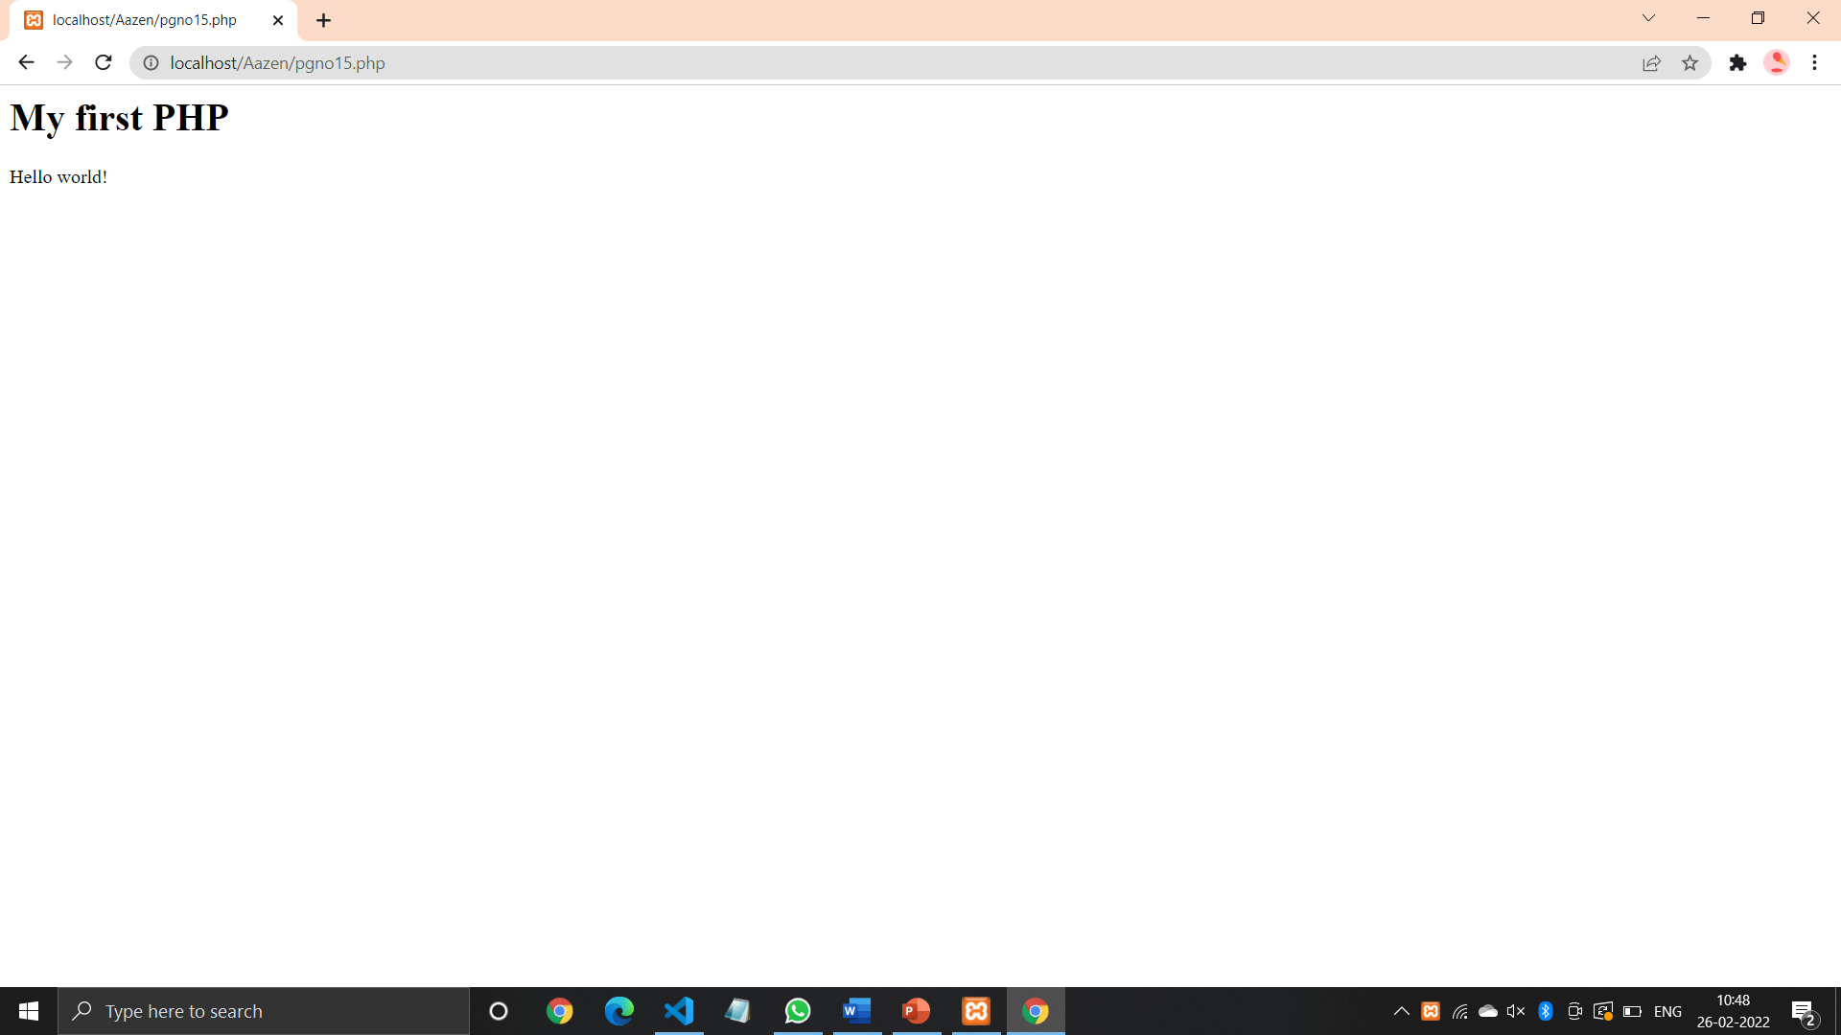

**Code (Pg no. 18):**

<html>

<head>

<title>

</title>

</head>

<body>

<h1>

<?php

echo " Hello world! ";

?>

</h1>

</body>

</html>

**Output:**

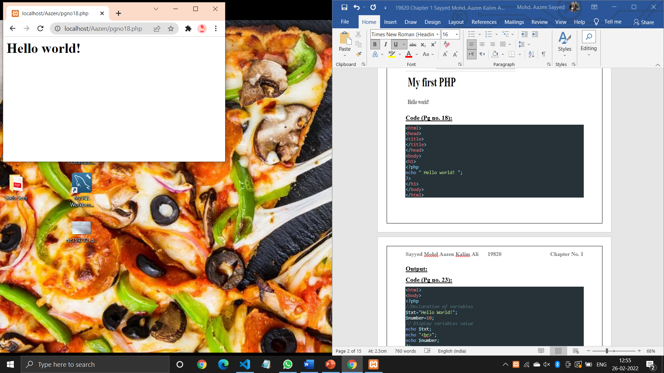

**Code (Pg no. 23):**

<html>

<body>

<?php

*//Declaration of variables*

$txt="Hello World!";

$number=10;

*// Display variables value*

echo $txt;

echo "<br>";

echo $number;

?>

</body>

</html>

**Output:**

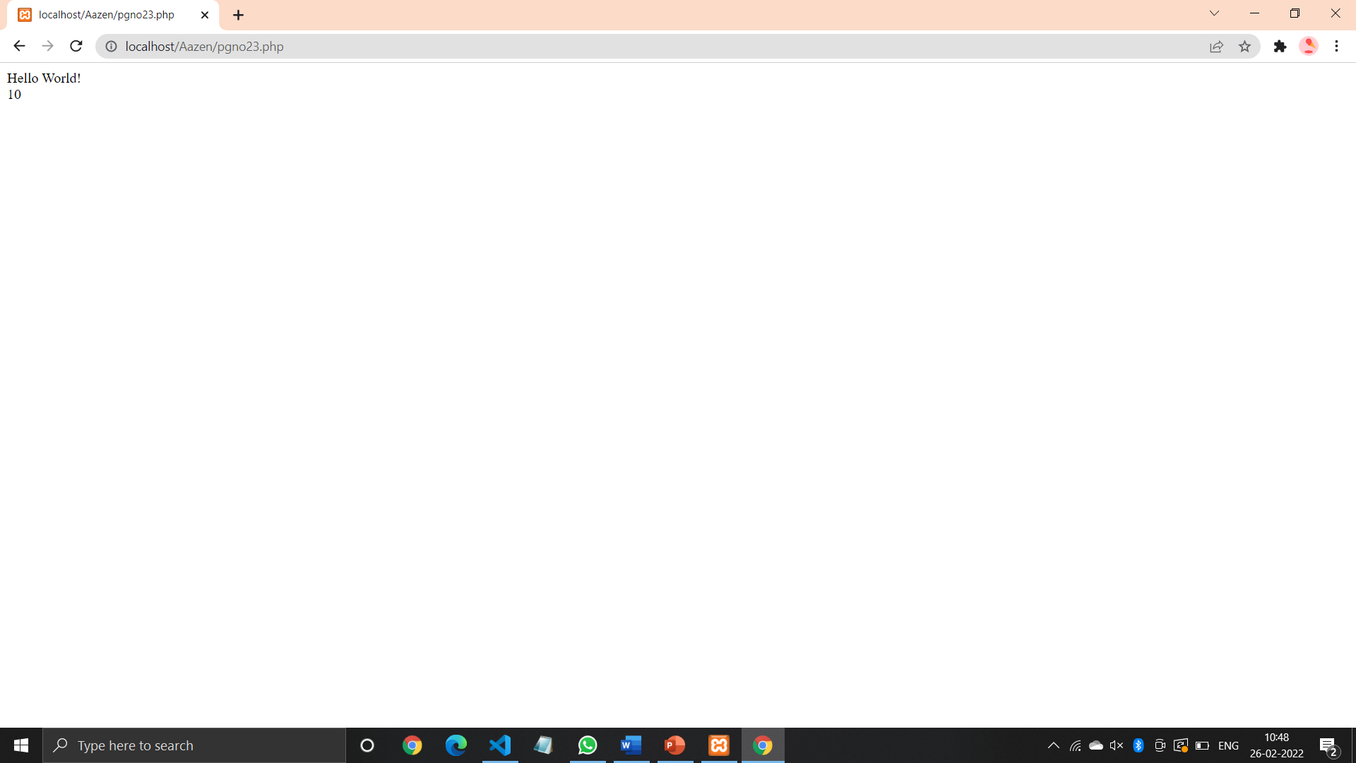

**Code (Pg no. 25):**

<?php

*//Displaying strings*

echo "Hello, Welcome to PHP Programming";

echo "<br/>";

*//Displaying Strings as Multiple arguments*

echo "Hello". " Welcome". " PHP";

echo "<br/>";

*//Displaying variables*

$s="Hello, PHP";

$x=10;

$y=20;

echo "$s </br>";

echo $x."+".$y."=";

echo $x + $y;

?>

**Output:**

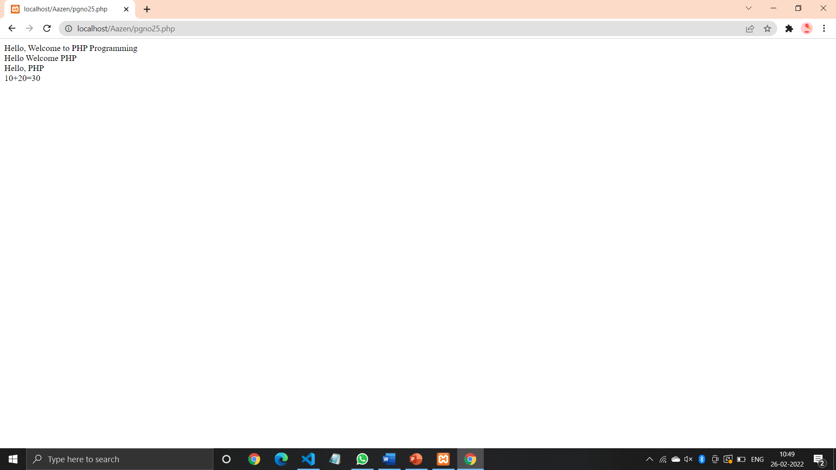

**Code (Pg no. 28):**

<?php

$var1="Hello PHP";

$var2="101";

$arr=array('0'=>"welcome",'1'=>"to","2"=>"PHP");

*//printing the variables*

print_r($var1);

echo"<br/>";

print_r($var2);

echo"<br/>";

print_r($arr);

?>

**Output:**

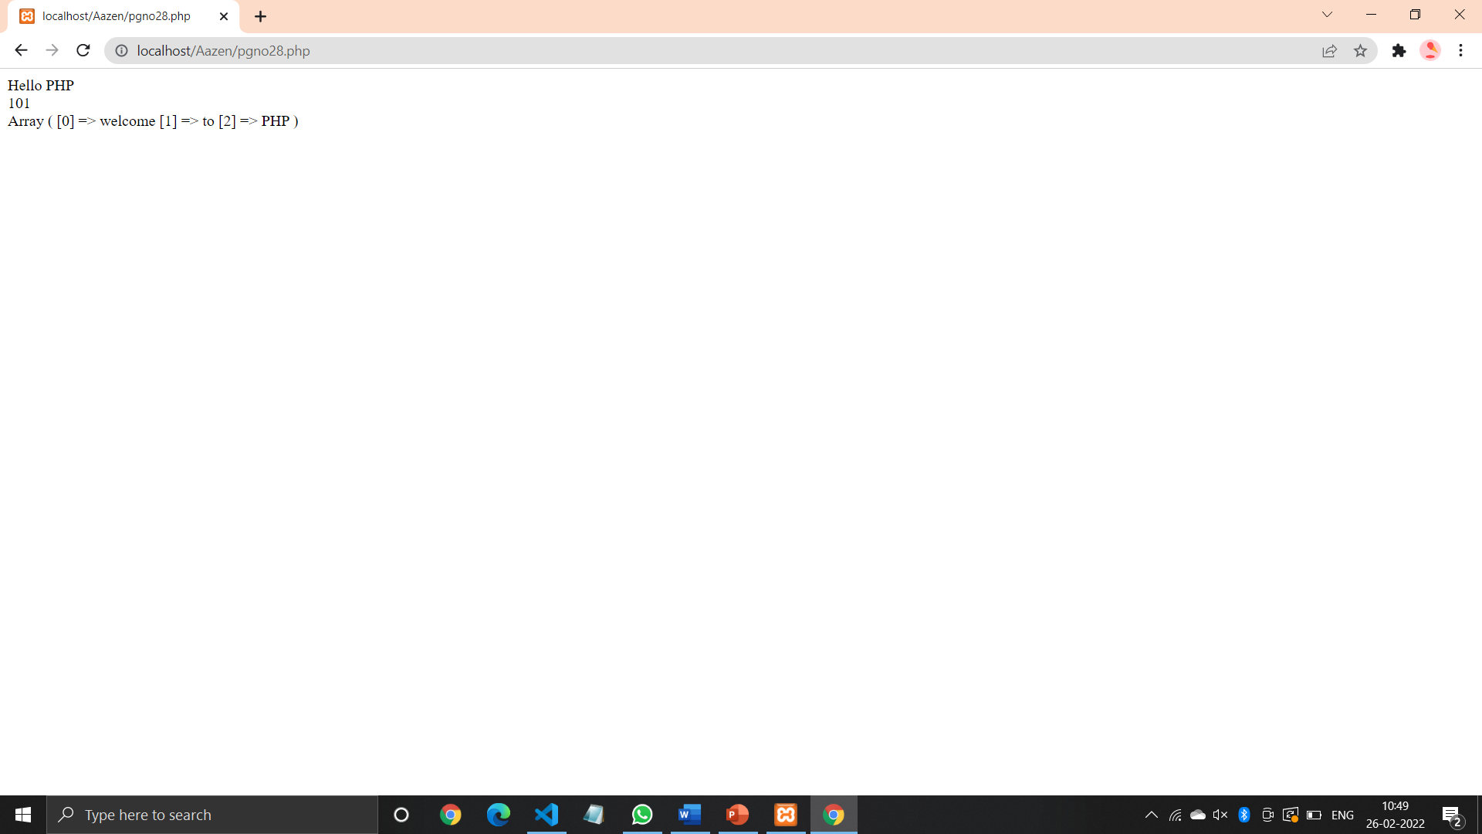

**Code (Pg no. 30):**

<html>

<head>

<title>

</title>

</head>

<body>

<h1>

<?php

echo " Hello world! ";

?>

</h1>

</body>

</html>

**Output:**

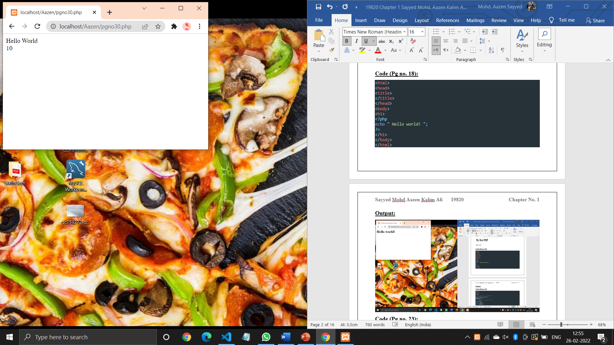

**Code (Pg no. 33):**

<?php

$num=20;

function local_var()

{

$num=10;

echo"Local num=$num<br/>";

}

echo"<br/>";

echo"Variable outside local_var=$num<br/>";

?>

**Output:**

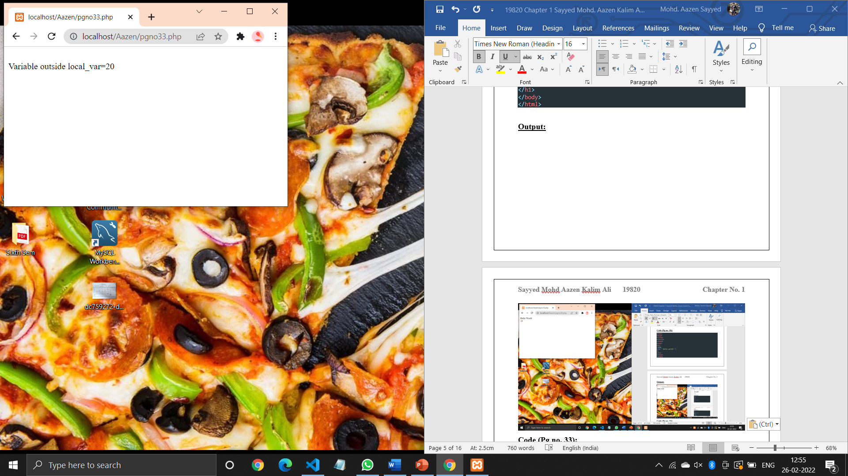

**Code (Pg no. 34):**

<?php

$num=20;

function local_var()

{ global $num;

echo"Access global variable within the function=$num<br/>";

} echo"<br/>";

echo"Global variable num outside of local_var()=$num<br/>";

?>

**Output:**

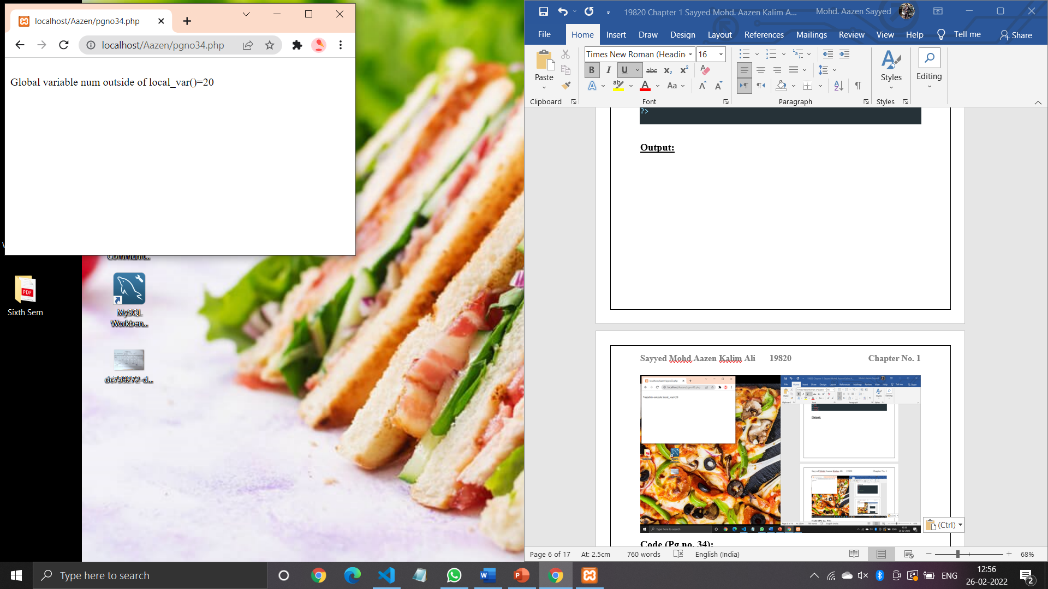

**Code (Pg no. 36):**

<?php

function static_var()

{

static $x=1;

$y=1;

$x++;

$y++;

echo"x=$x<br/>";

echo"y=$y<br/>";

}

static_var();

static_var();

static_var();

?>

**Output:**

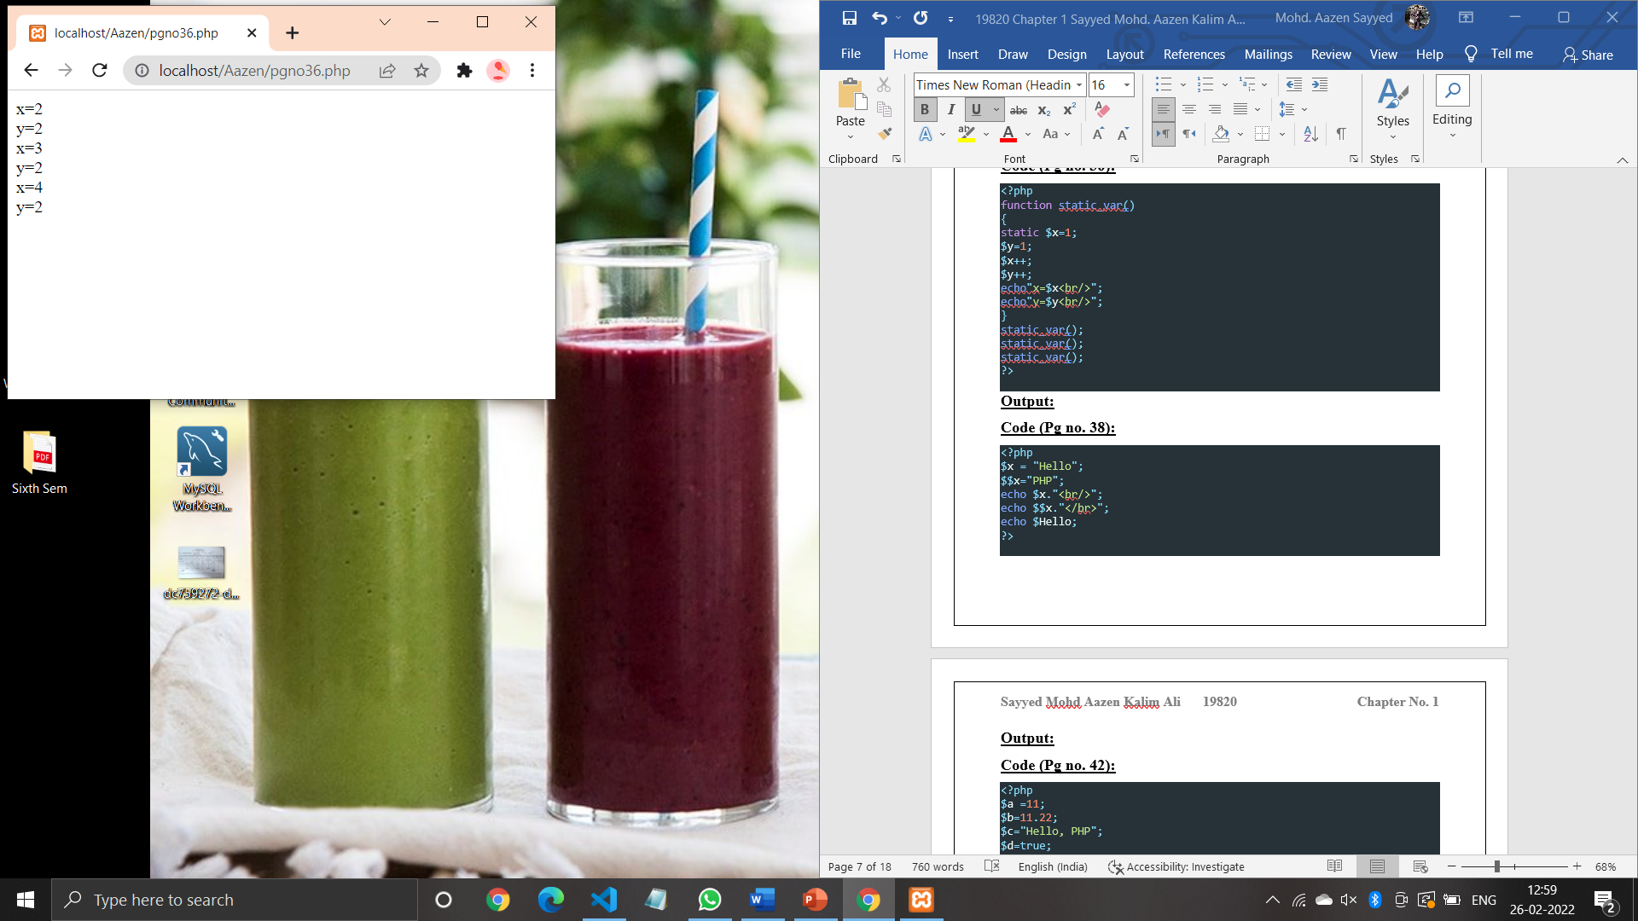

**Code (Pg no. 38):**

<?php

$x = "Hello";

$$x="PHP";

echo $x."<br/>";

echo $$x."</br>";

echo $Hello;

?>

**Output:**

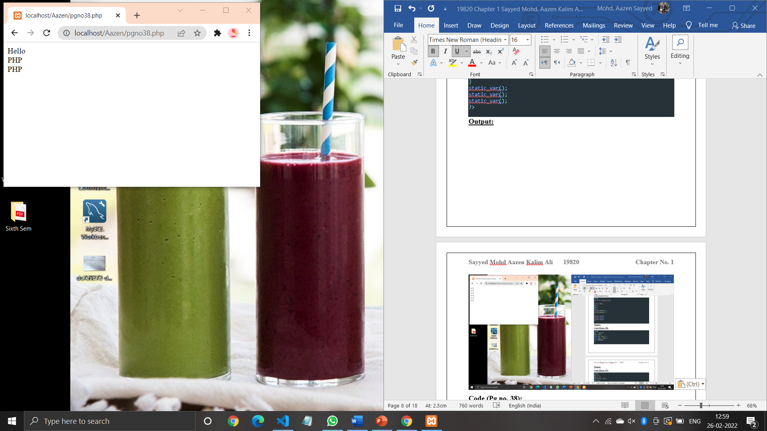

**Code (Pg no. 42):**

<?php

$a =11;

$b=11.22;

$c="Hello, PHP";

$d=true;

var_dump($a);

echo"<br/>";

var_dump($b);

echo"<br/>";

var_dump($c);

echo"<br/>";

var_dump($d);

?>

**Output:**

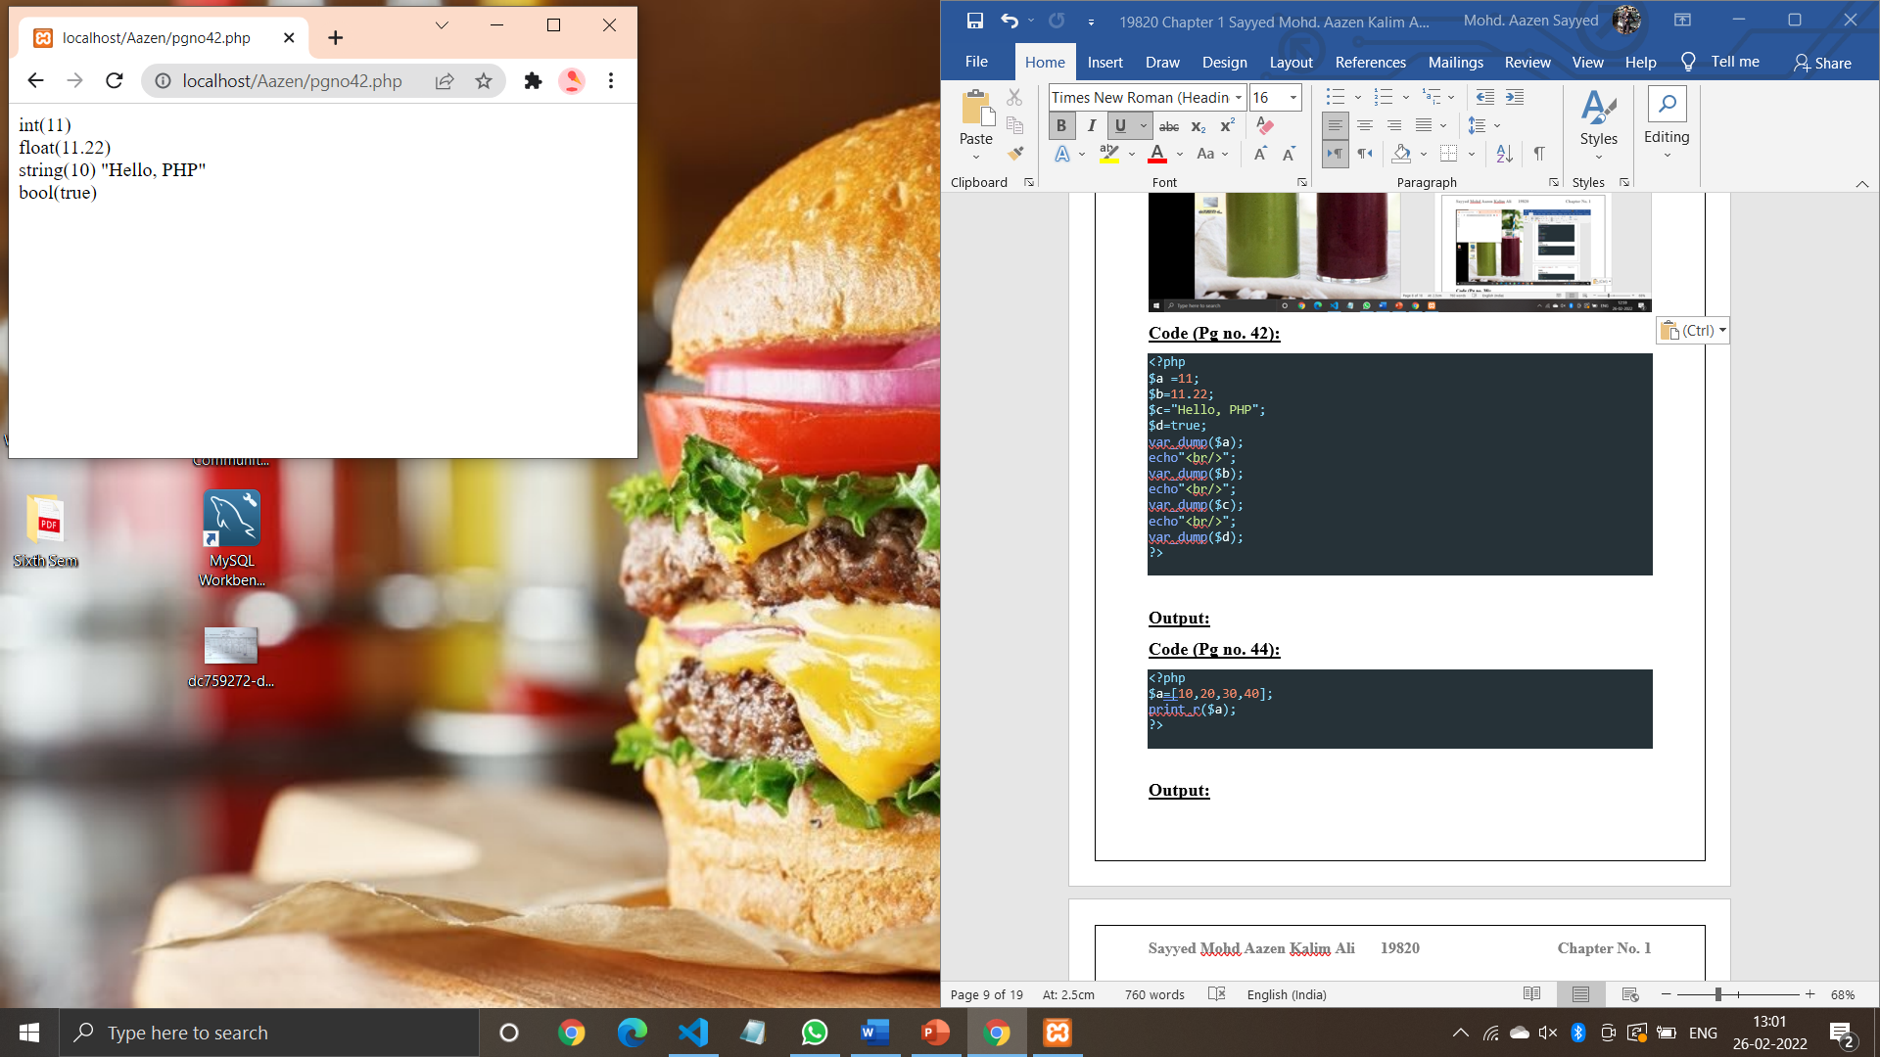

**Code (Pg no. 44):**

<?php

$a=[10,20,30,40];

print_r($a);

?>

**Output:**

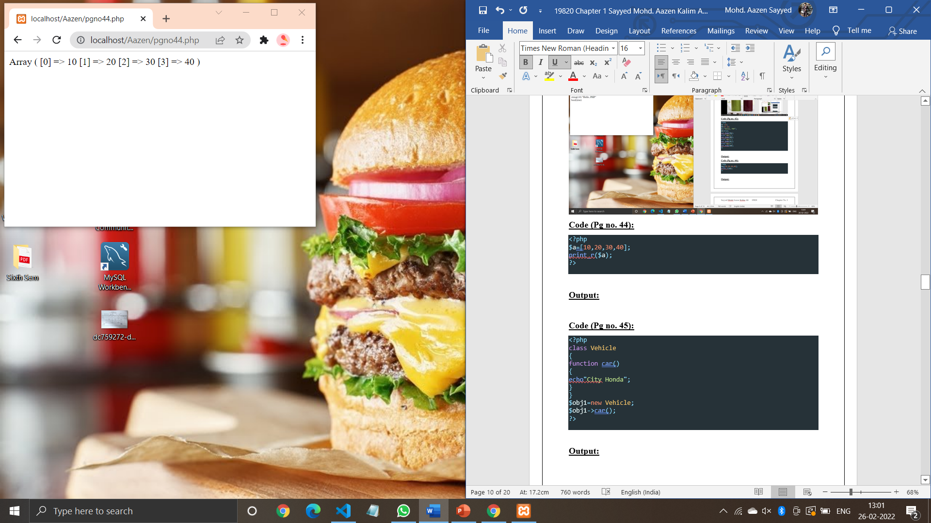

**Code (Pg no. 45):**

<?php

class Vehicle

{

function car()

{

echo"City Honda";

}

}

$obj1=new Vehicle;

$obj1->car();

?>

**Output:**

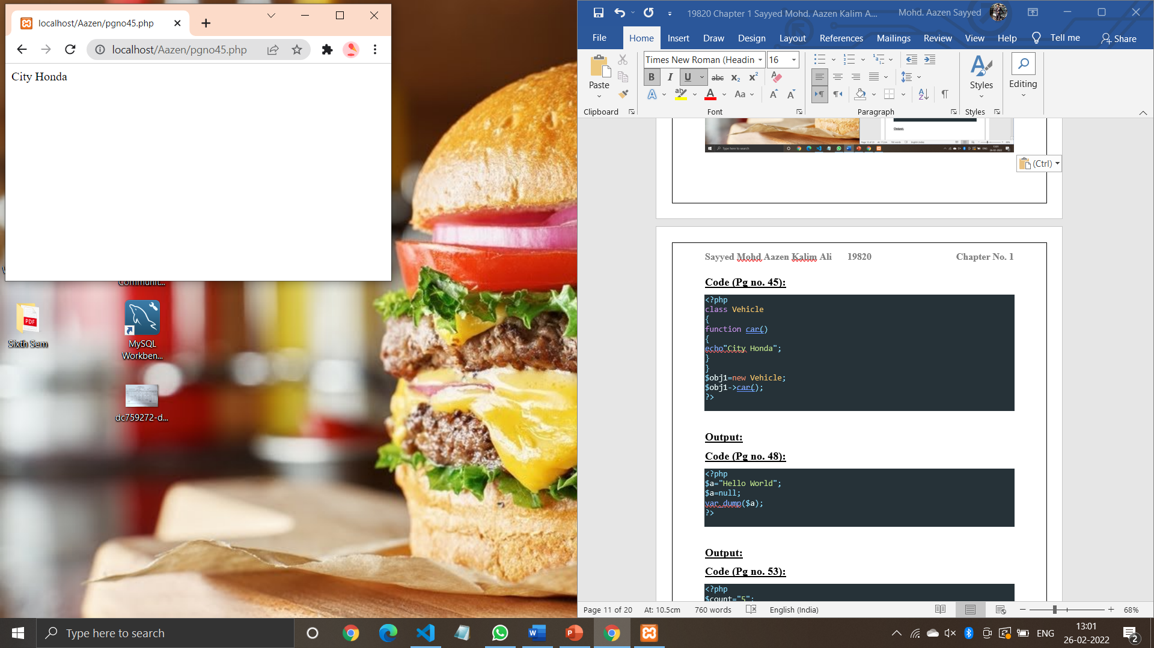

**Code (Pg no. 48):**

<?php

$a="Hello World";

$a=null;

var_dump($a);

?>

**Output:**

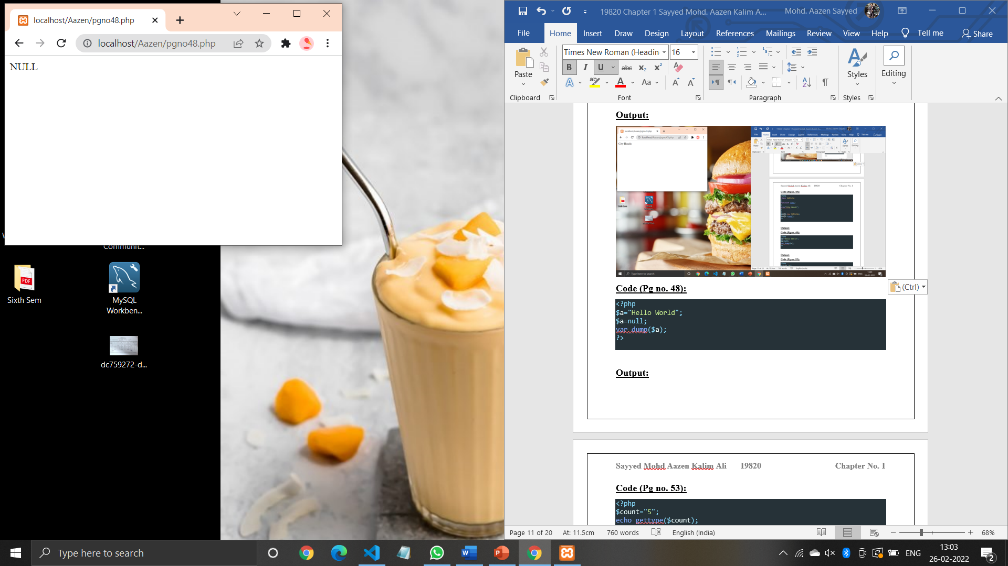

**Code (Pg no. 53):**

<?php

$count="5";

echo gettype($count);

settype($count,'int');

echo"<br/>";

echo gettype($count);

?>

**Output:**

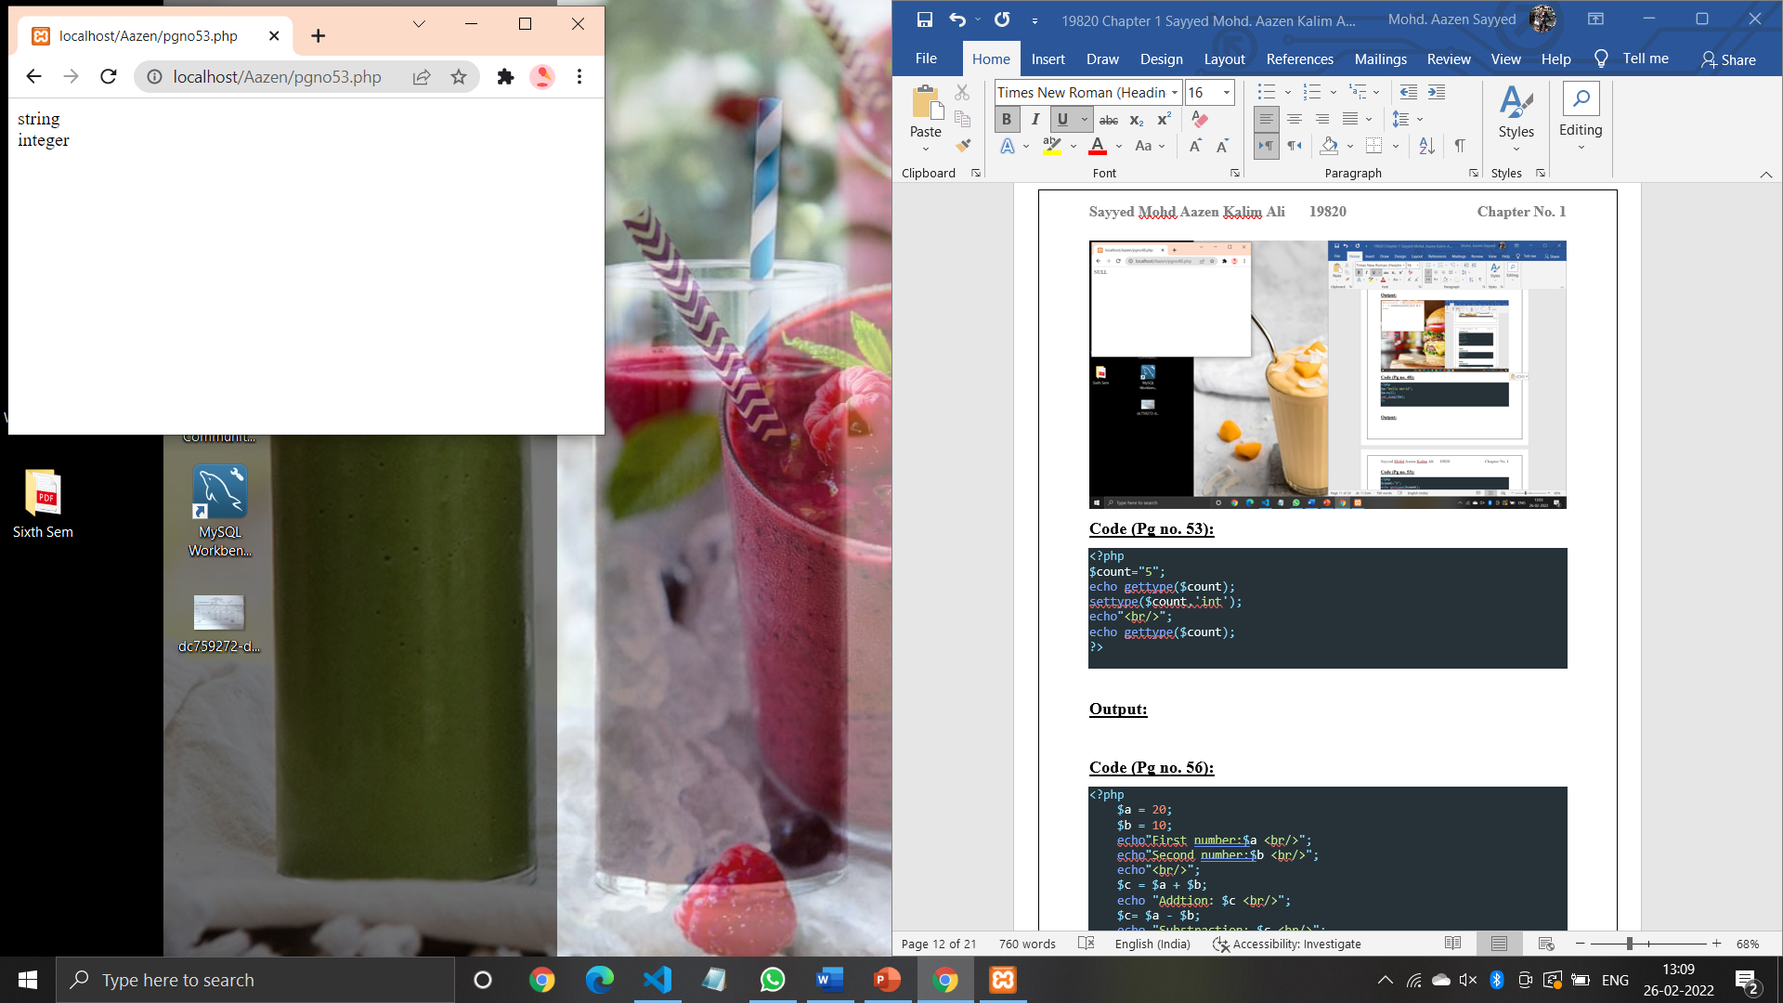

**Code (Pg no. 56):**

<?php

    $a = 20;

    $b = 10;

    echo"First number:$a <br/>";

    echo"Second number:$b <br/>";

    echo"<br/>";

    $c = $a + $b;

    echo "Addtion: $c <br/>";

    $c= $a - $b;

    echo "Substraction: $c <br/>";

    $c= $a*$b;

    echo "Multiplication: $c <br/>";

    $c= $a/$b;

    echo "Division: $c <br/>";

    $c = $a%$b;

    echo "Modulus: $c<br/>";

    $c = $a**$b;

    echo "Exponential: $c<br/>";

?>

**Output:**

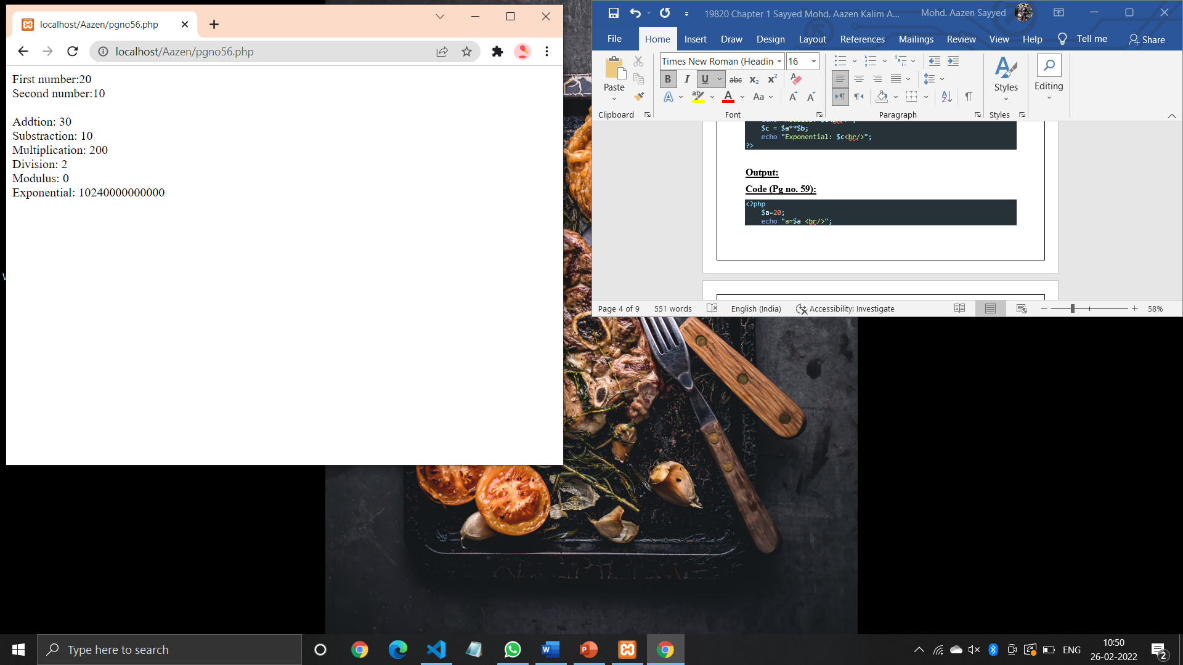

**Code (Pg no. 59):**

<?php

    $a=20;

    echo "a=$a <br/>";

    $a+=10;

    echo "a=a+10 : $a <br/>";

    $a-=10;

    echo "a=a-10 :$a <br/>";

    $a* 10;

    echo "a=a*10 :$a <br/>";

    $a/=10;

    echo "a=a/10:$a <br>";

    $a%=2;

    echo "a=a%2:$a <br>";

?>

**Output:**

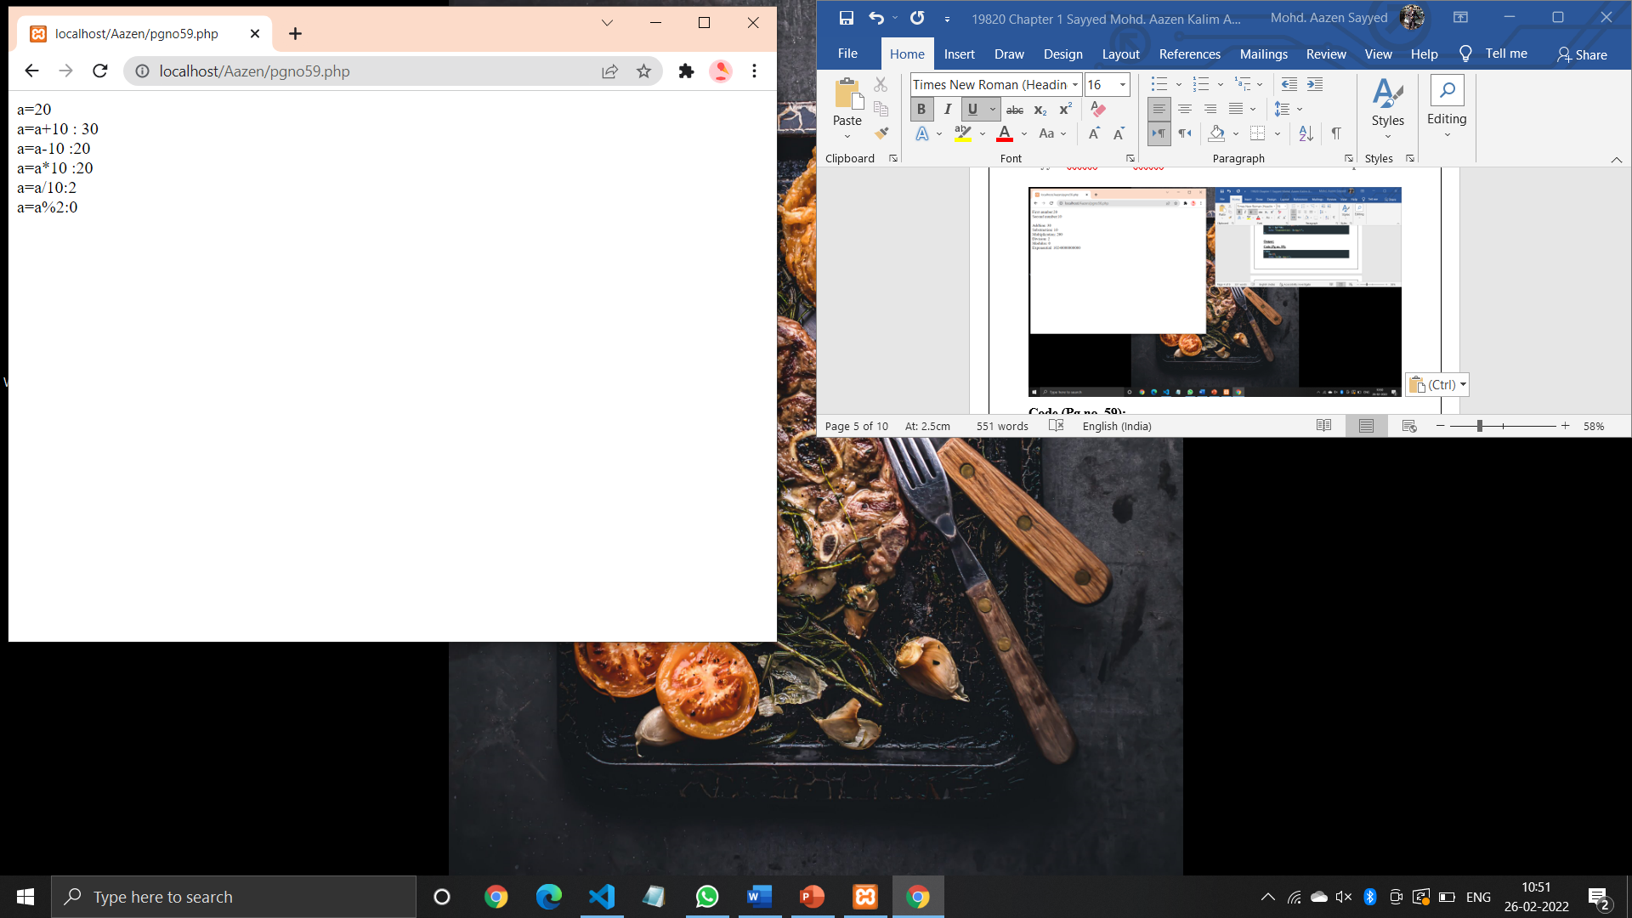

**Code (Pg no. 62):**

<?php

$a=20;

$b=10;

$c=20;

var_dump($a == $c);

echo "<br/>";

var_dump($a != $b);

echo "<br/>";

var_dump($a <> $b);

echo "<br/>";

var_dump($a === $c);

echo "<br/>";

var_dump($a !== $c);

echo "<br/>";

var_dump($a < $b) ;

echo "<br/>";

var_dump($a > $b);

echo "<br/>";

var_dump($a <= $b);

echo "<br/>";

var_dump($a >= $b);

?>

**Output:**

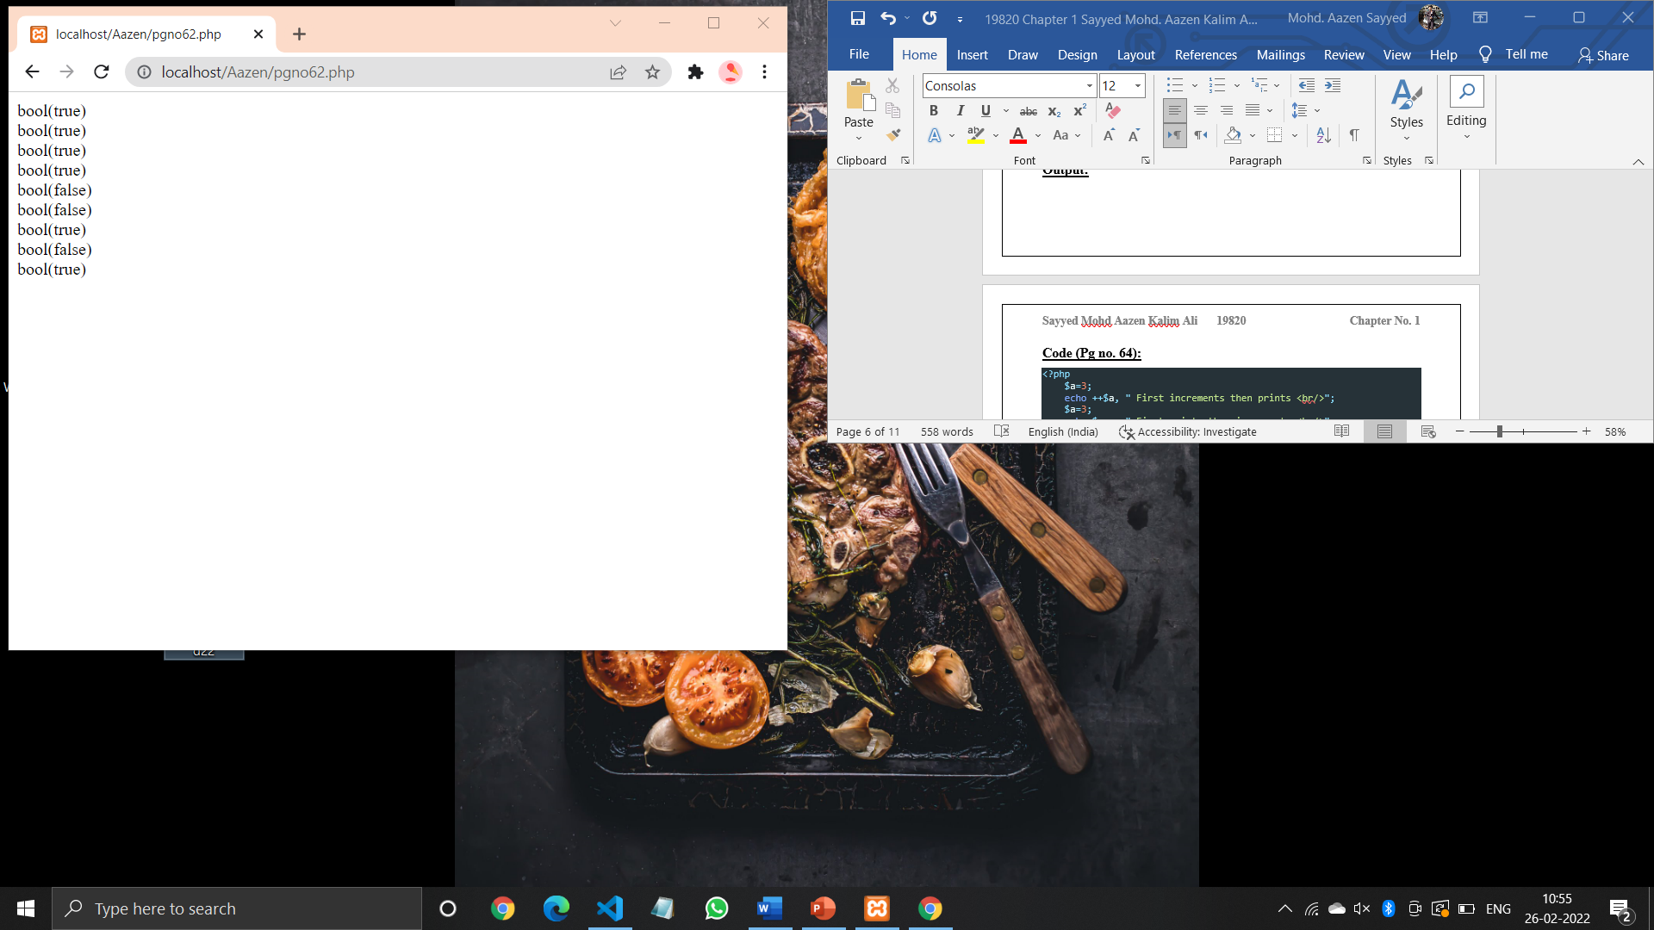

**Code (Pg no. 64):**

<?php

    $a=3;

    echo ++$a, " First increments then prints <br/>";

    $a=3;

    echo $a++, " First prints then increments <br/>";

    $a = 3;

    echo-$a, " First decrements then prints <br/>";

    $a = 3;

    echo $a--, " First prints then decrements <br/>";

?>

**Output:**

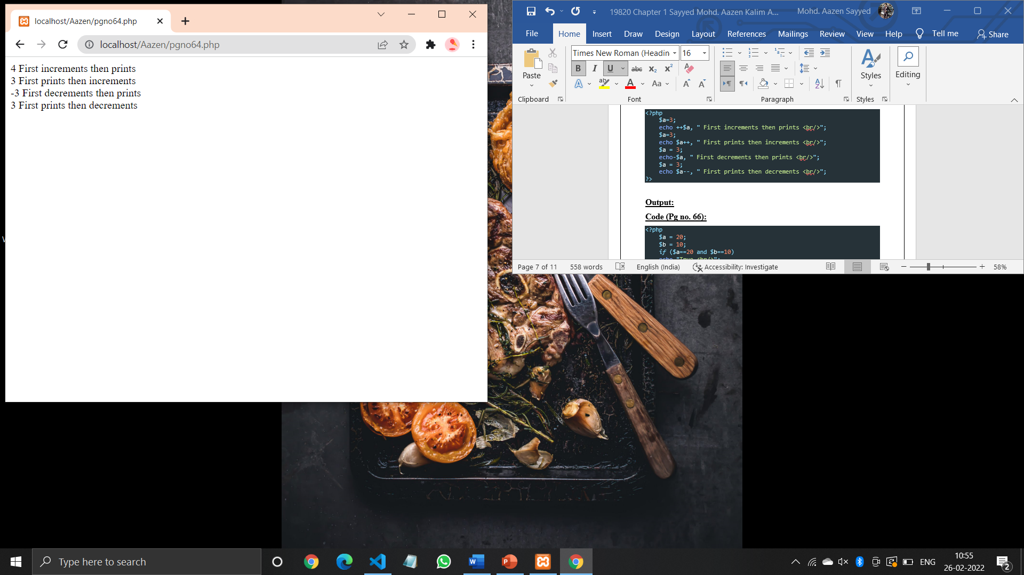

**Code (Pg no. 66):**

<?php

    $a = 20;

    $b = 10;

*if* ($a==20 and $b==10)

    echo "True <br/>";

*if* ($a==20 or $b==30)

    echo "True <br/>";

*if* ($a==20 xor $b==5)

    echo "True <br/>";

*if* ($a==20 && $b==10)

    echo "True <br/>";

*if* ($a==20||$b==20)

    echo "True <br/>";

?>

**Output:**

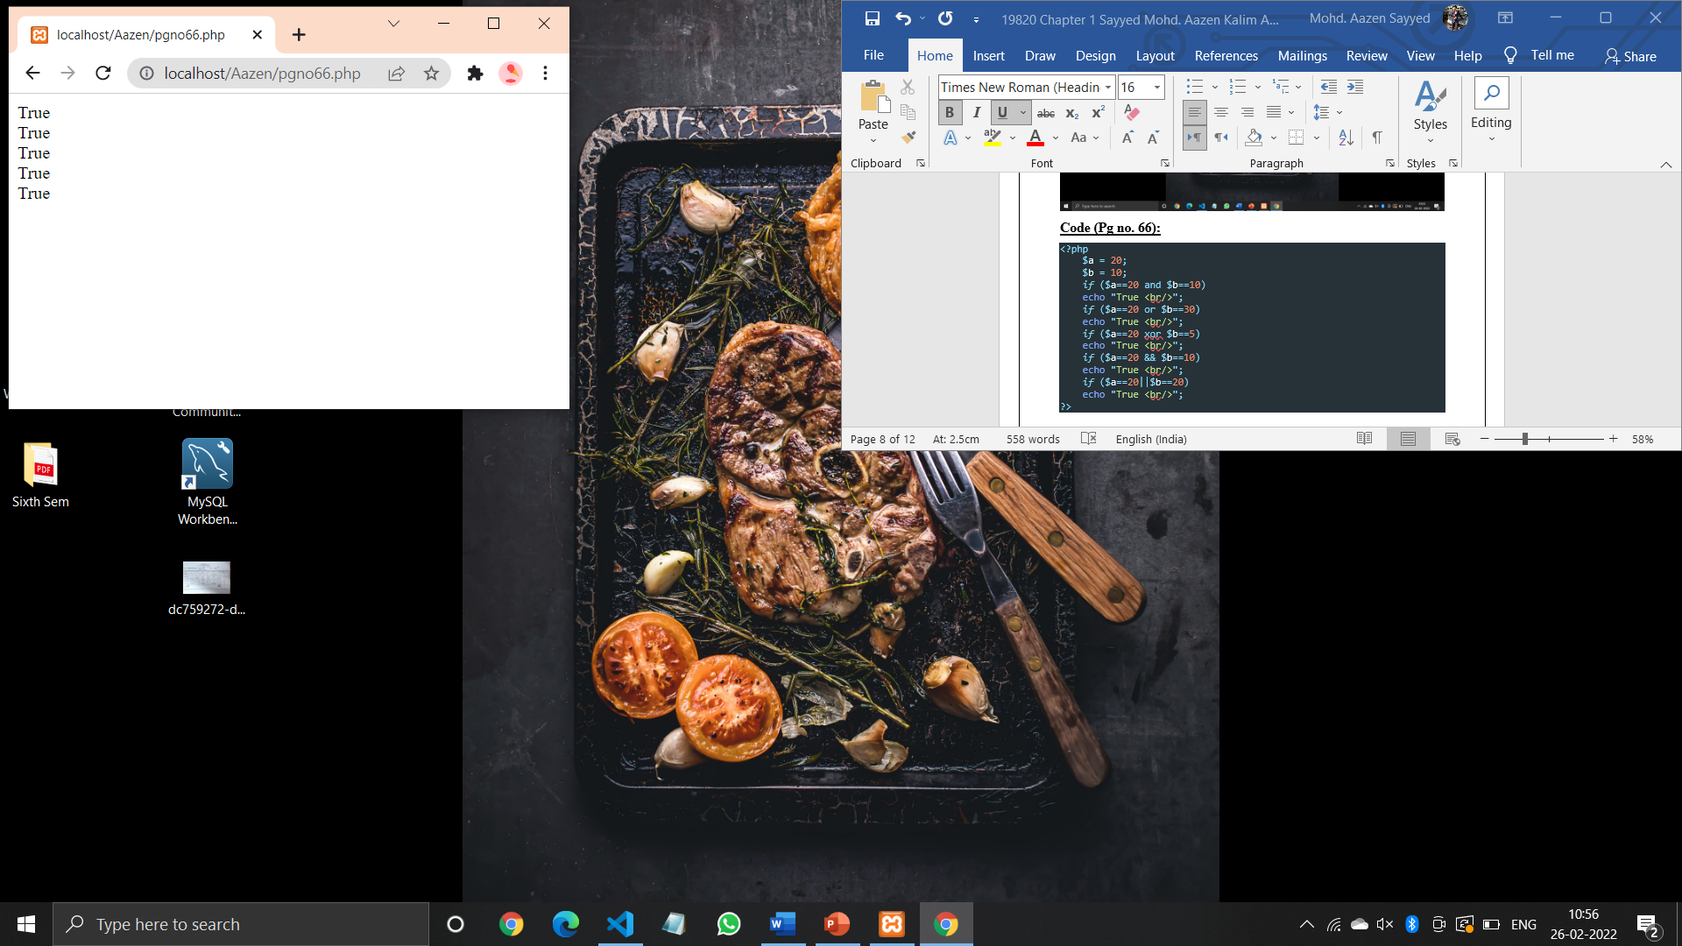

**Code (Pg no. 68):**

<?php

*//first string*

$a="Hello";

*//second string*

$b="World";

*//concatenation of string*

$c=$a.$b;

echo "$c <br/>";

*//$a contains HelloPHP*

$a.="PHP";

echo "$a";

?>

**Output:**

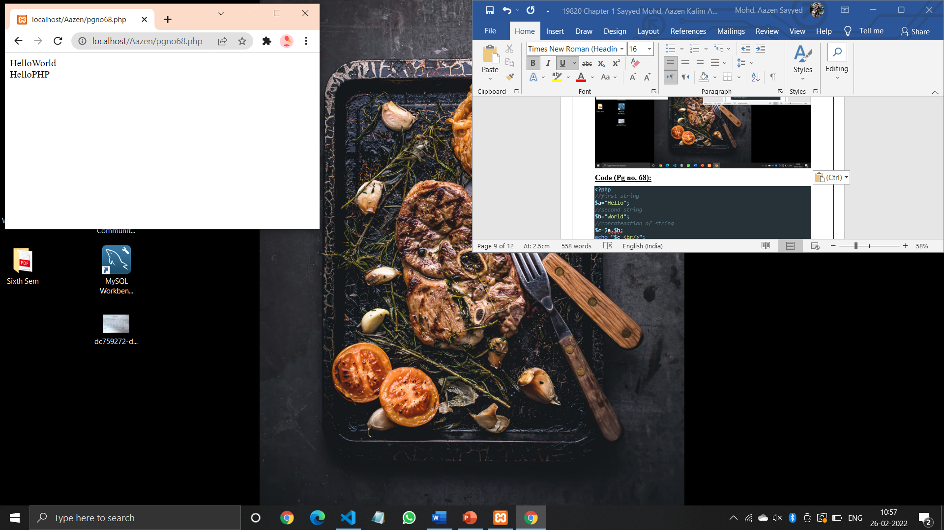

**Code (Pg no. 70):**

<?php

    $a = array("a"=>"C","b"=>"Perl");

    $b = array("d"=>"Java","e"=>"Python");

    var_dump($a + $b);

    echo "</br>";

    var_dump($a == $b);

    echo "</br>";

    var_dump($a != $b);

    echo "</br>";

    var_dump($a<>$b);

    echo "</br>";

    var_dump($a===$b);

    echo "</br>";

    var_dump($a !== $b);

    echo "</br>";

?>

**Output:**

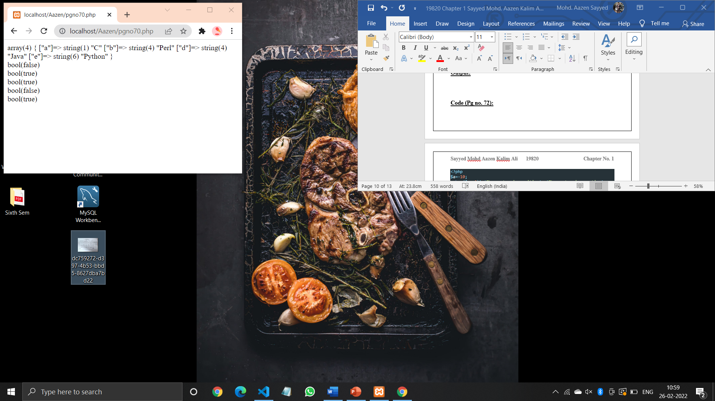

**Code (Pg no. 72):**

<?php

$a=-10;

echo ($a> 0)? 'The number is positive': 'The number is negative';

?>

**Output:**

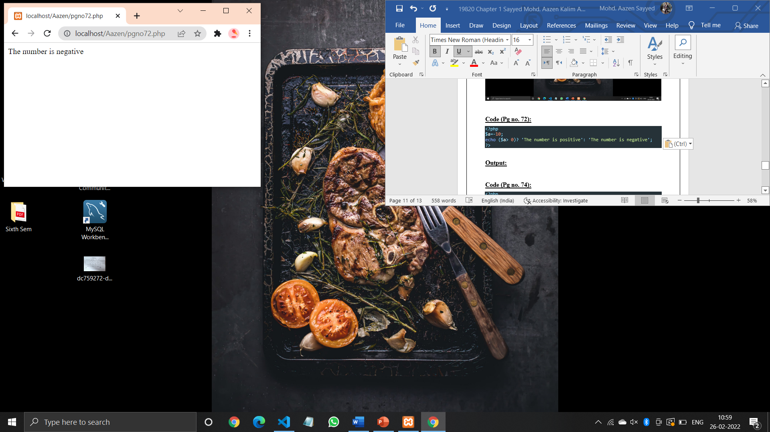

**Code (Pg no. 74):**

<?php

    $a=30;

    $b=30;

    $c=20;

    echo $a <> $b; echo "<br/>";

    echo $a <=> $c;

    echo "<br/>";

    echo $c <=> $b;

    echo "<br/>";

?>

**Output:**

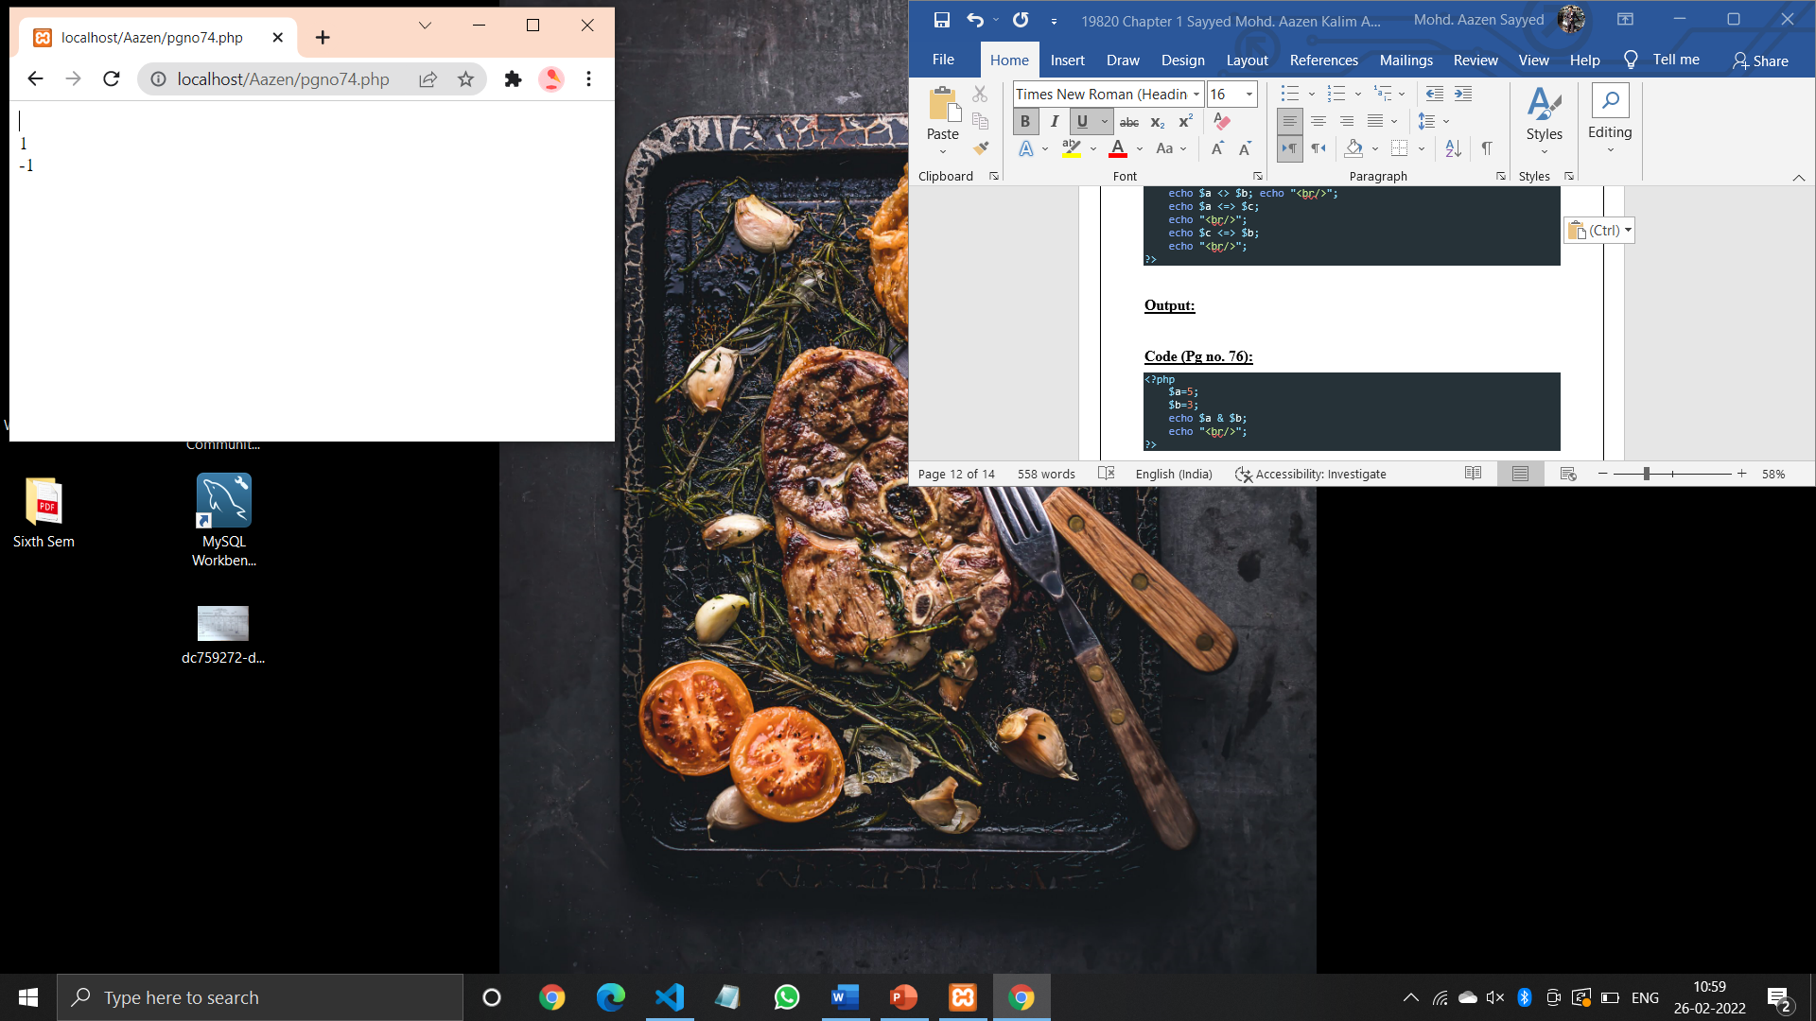

**Code (Pg no. 76):**

<?php

    $a=5;

    $b=3;

    echo $a & $b;

    echo "<br/>";

?>

**Output:**

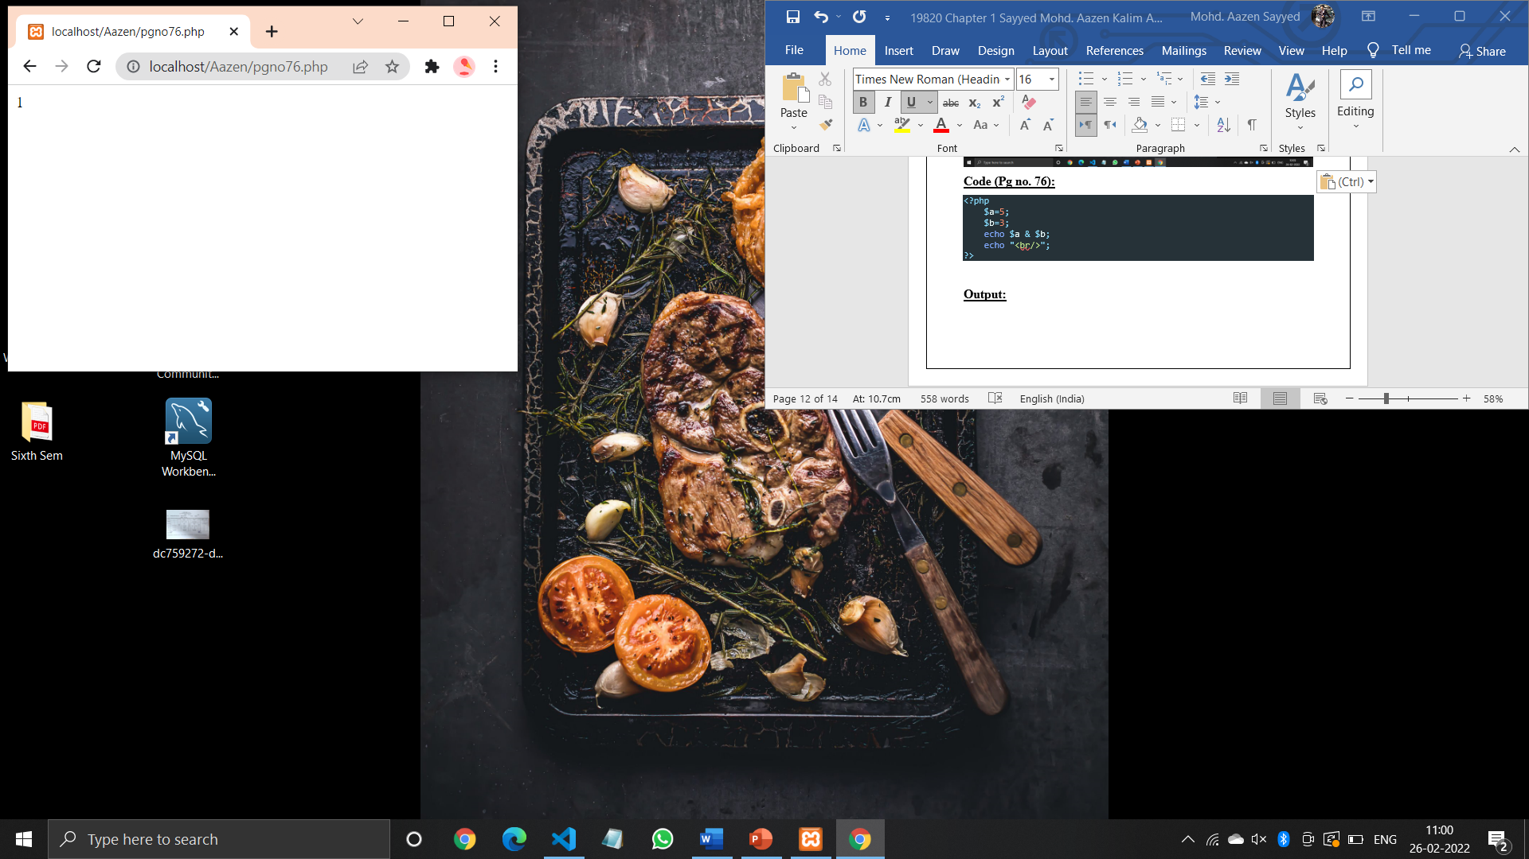

**Code (Pg no. 77):**

<?php

$a=5;

$b=3;

echo $a|$b;

echo "<br/>";

?>

**Output:**

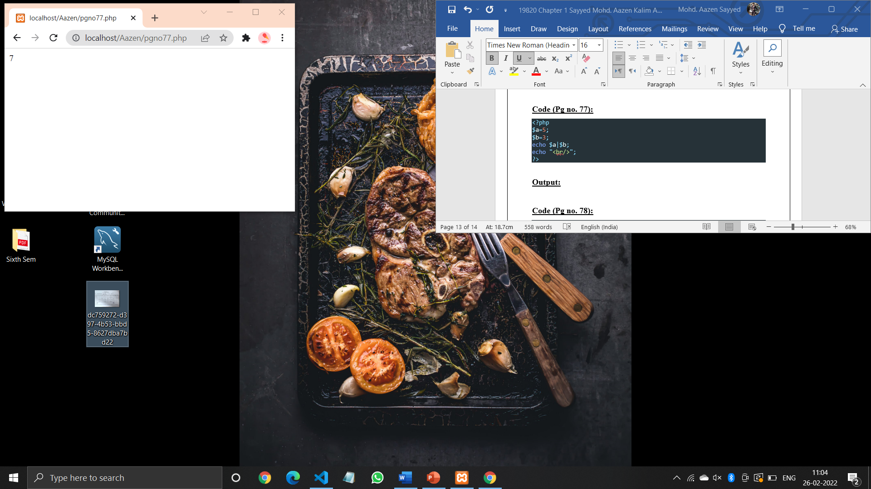

**Code (Pg no. 78):**

<?php

$a=5;

$b=3;

echo $a^$b;

echo "<br/>";

?>

**Output:**

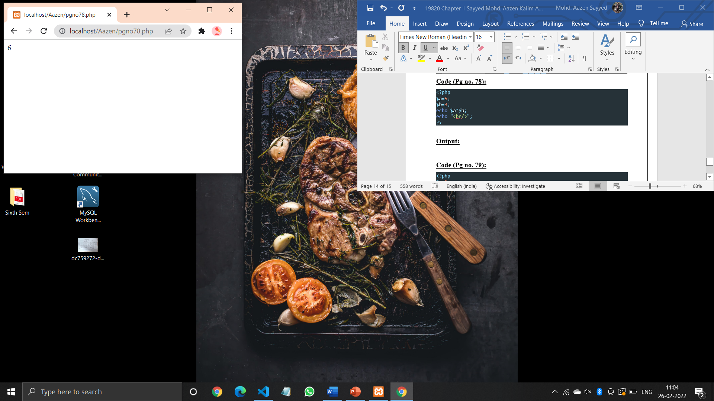

**Code (Pg no. 79):**

<?php

$a=5;

echo ~$a;

echo "<br/>";

?>

**Output:**

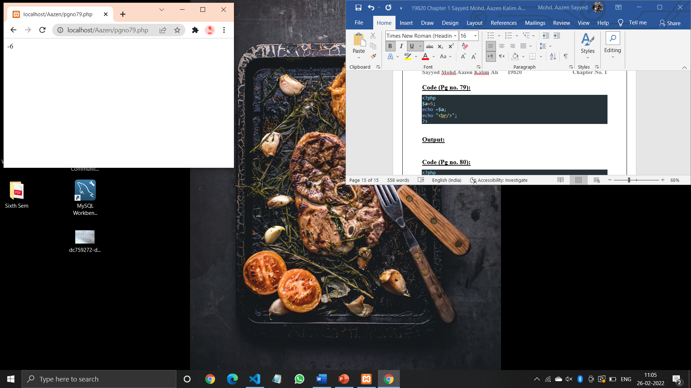

**Code (Pg no. 80):**

<?php

$a=5;

$b=1;

echo $a<<$b;

echo "<br/>";

?>

**Output:**

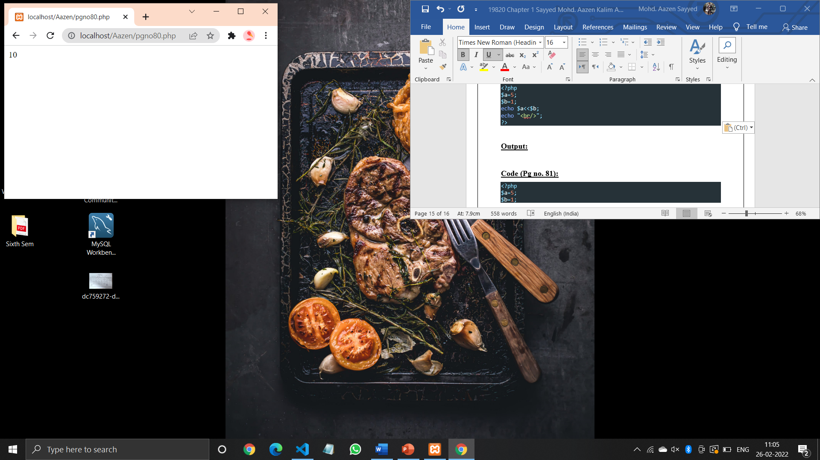

**Code (Pg no. 81):**

<?php

$a=5;

$b=1;

echo $a>>$b;

echo "<br/>";

?>

**Output:**

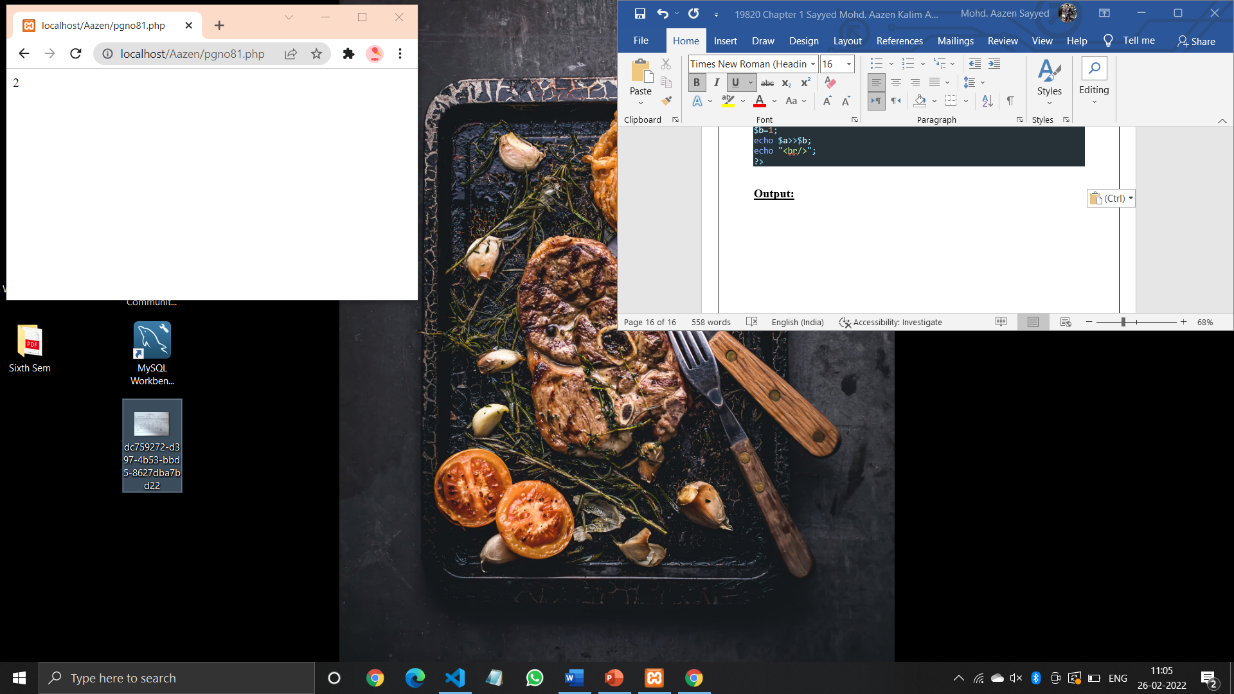

**Code (Pg no. 84):**

<?php

$n1=10;

$n2=5;

$n3=2;

$ans= $n1+$n2*$n3;

echo "$n1+$n2*$n3=$ans<br/>";

$ans=($n1+$n2)*$n3;

echo "($n1+$n2)*$n3=$ans<br/>";

?>

**Output:**

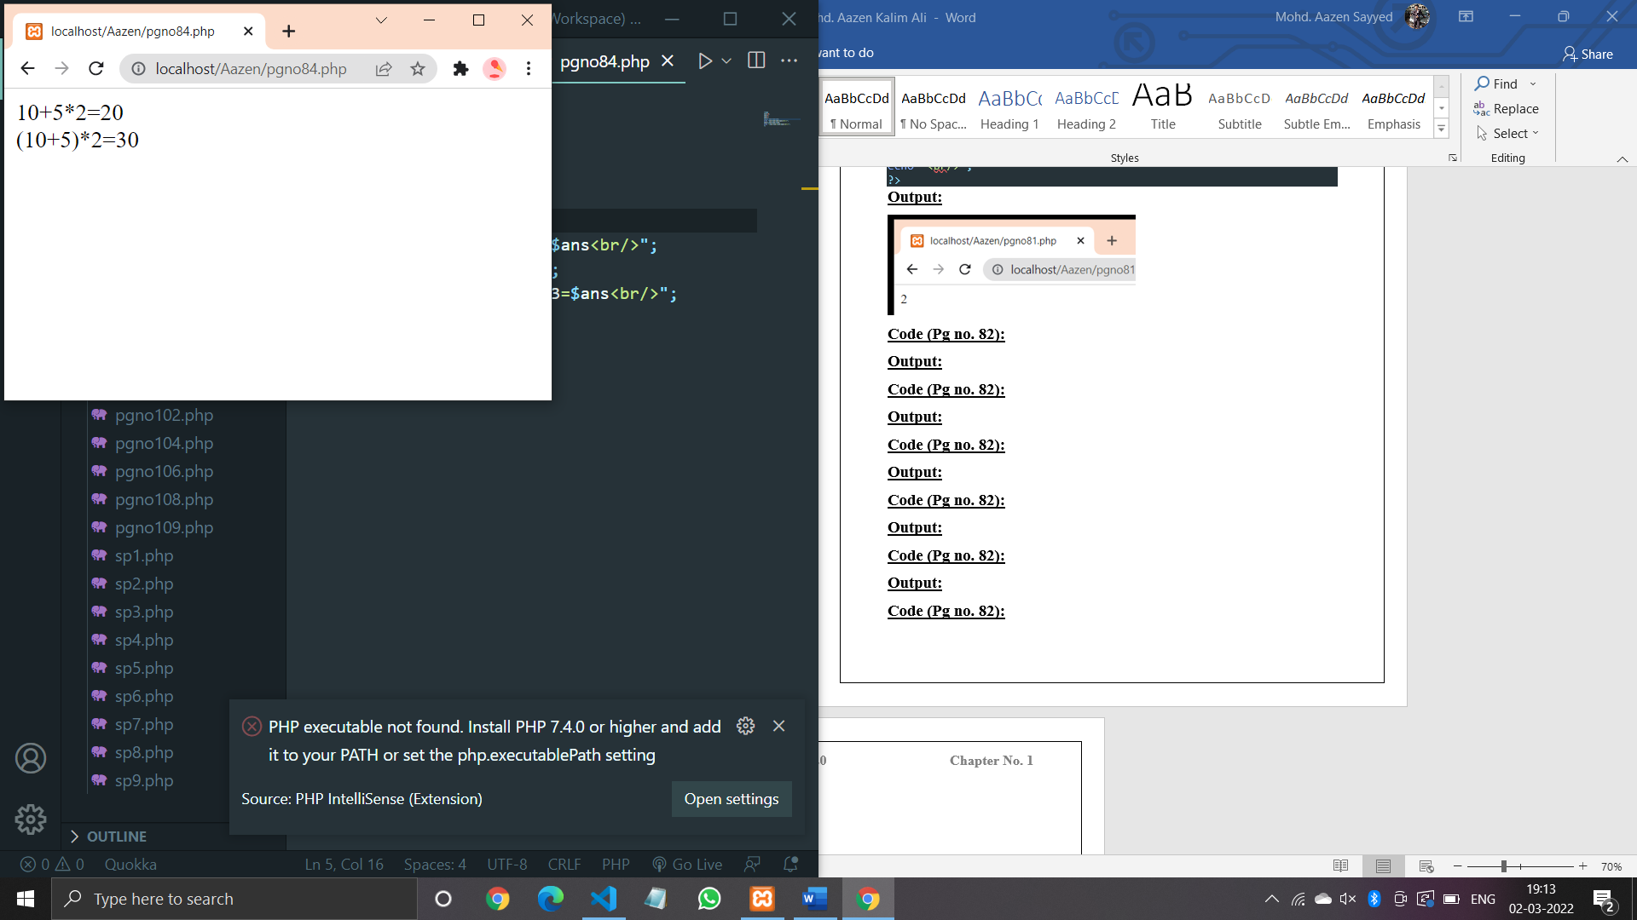

**Code (Pg no. 86):**

<?php

define("HELLO","Hello PHP");

echo HELLO,"<br/>";

define("HELLO","Hello PHP");

echo hello;

?>

**Output:**

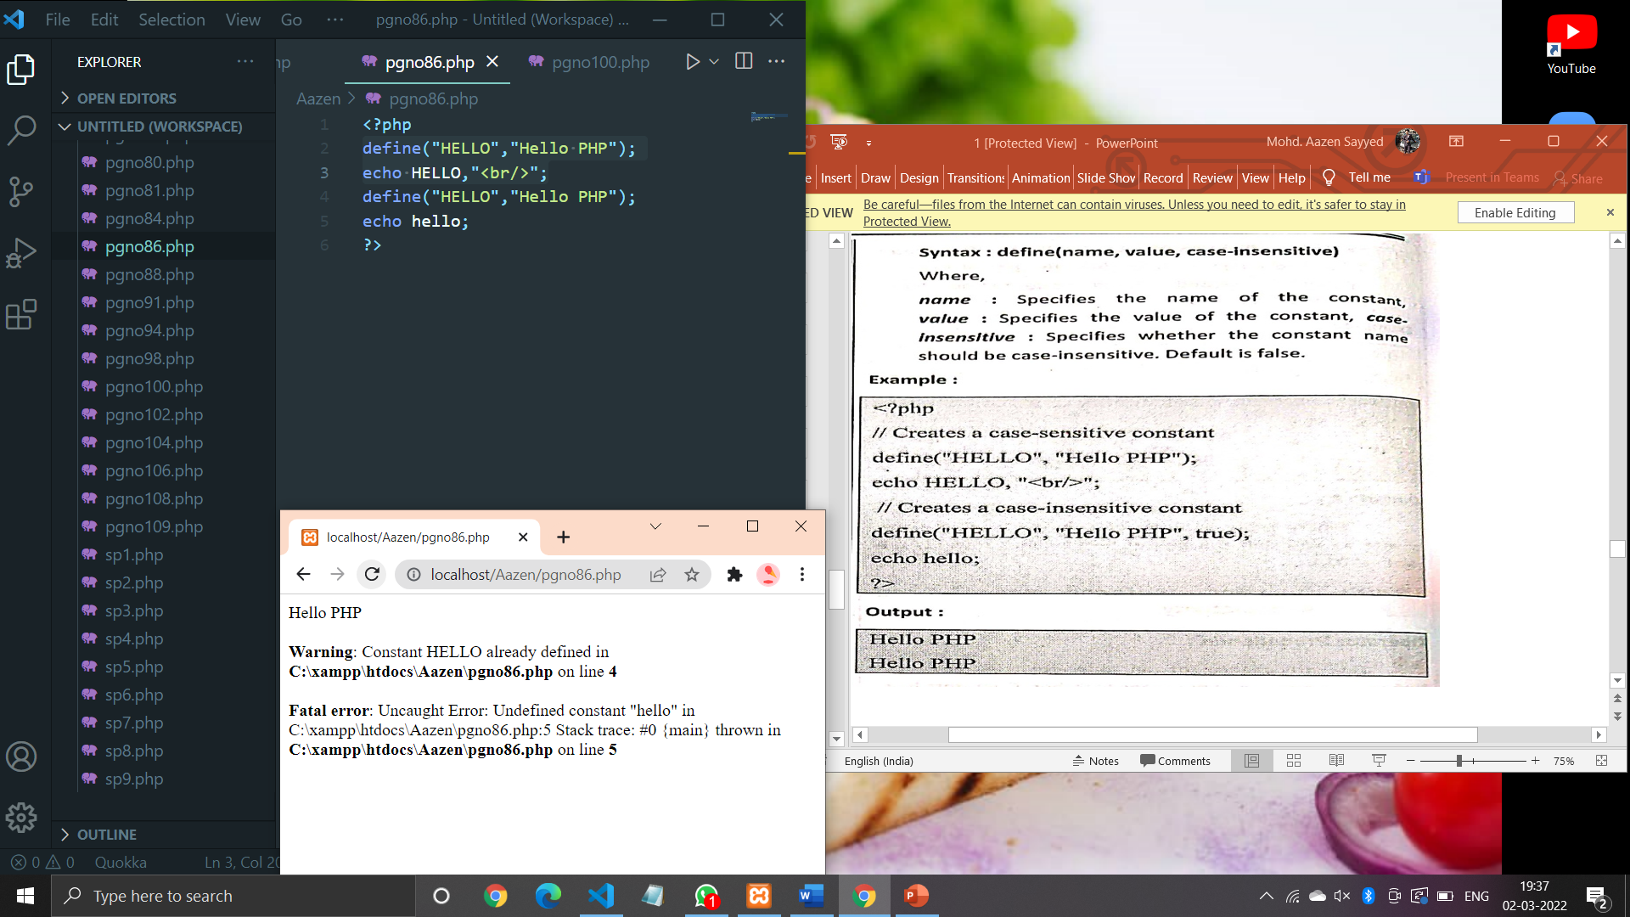

**Code (Pg no. 88):**

<?php

$a=10;

*if*($a>0)

{

    echo "The number is positive";

}

?>

**Output:**

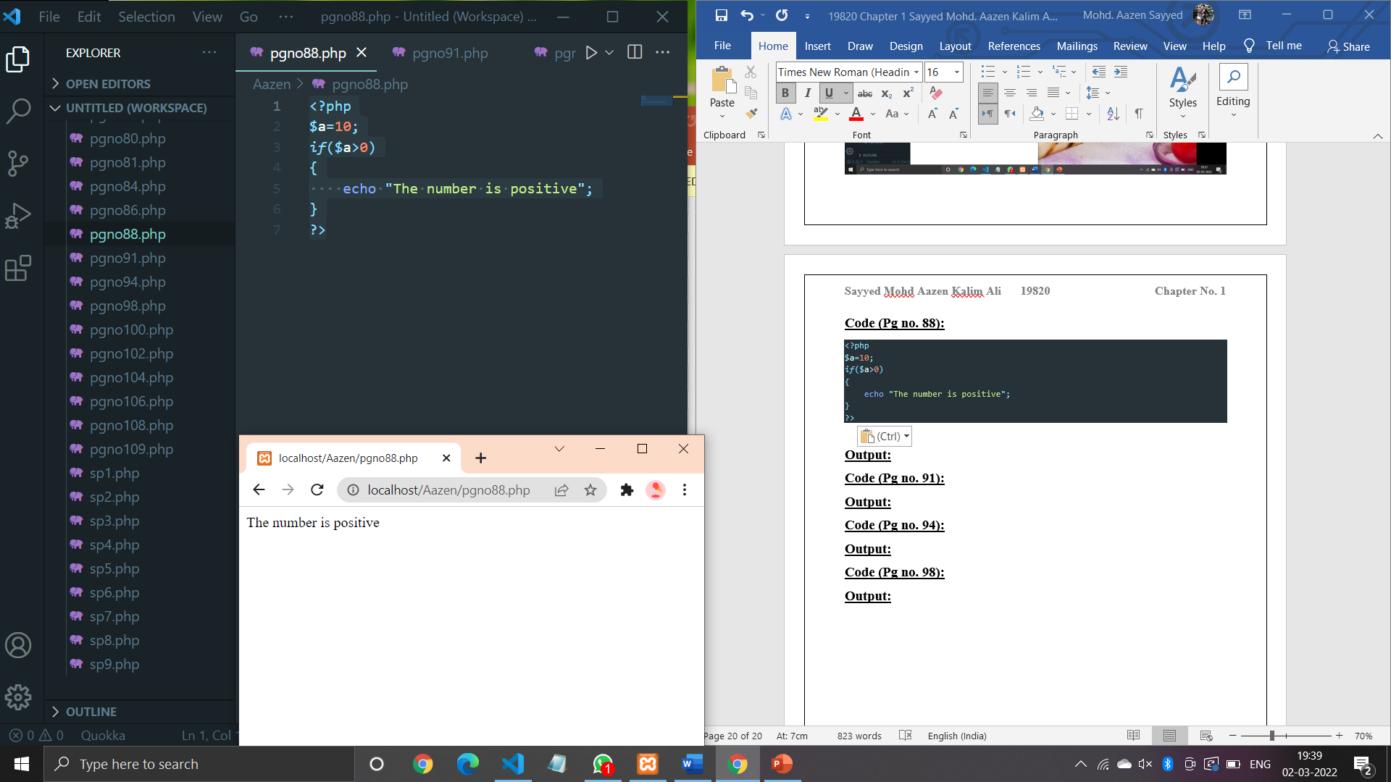

**Code (Pg no. 91):**

<?php

$a=-10;

*if*($a>0)

{

    echo "The number is positive";

}

*else*

{

    echo "The number is negative";

}

?>

**Output:**

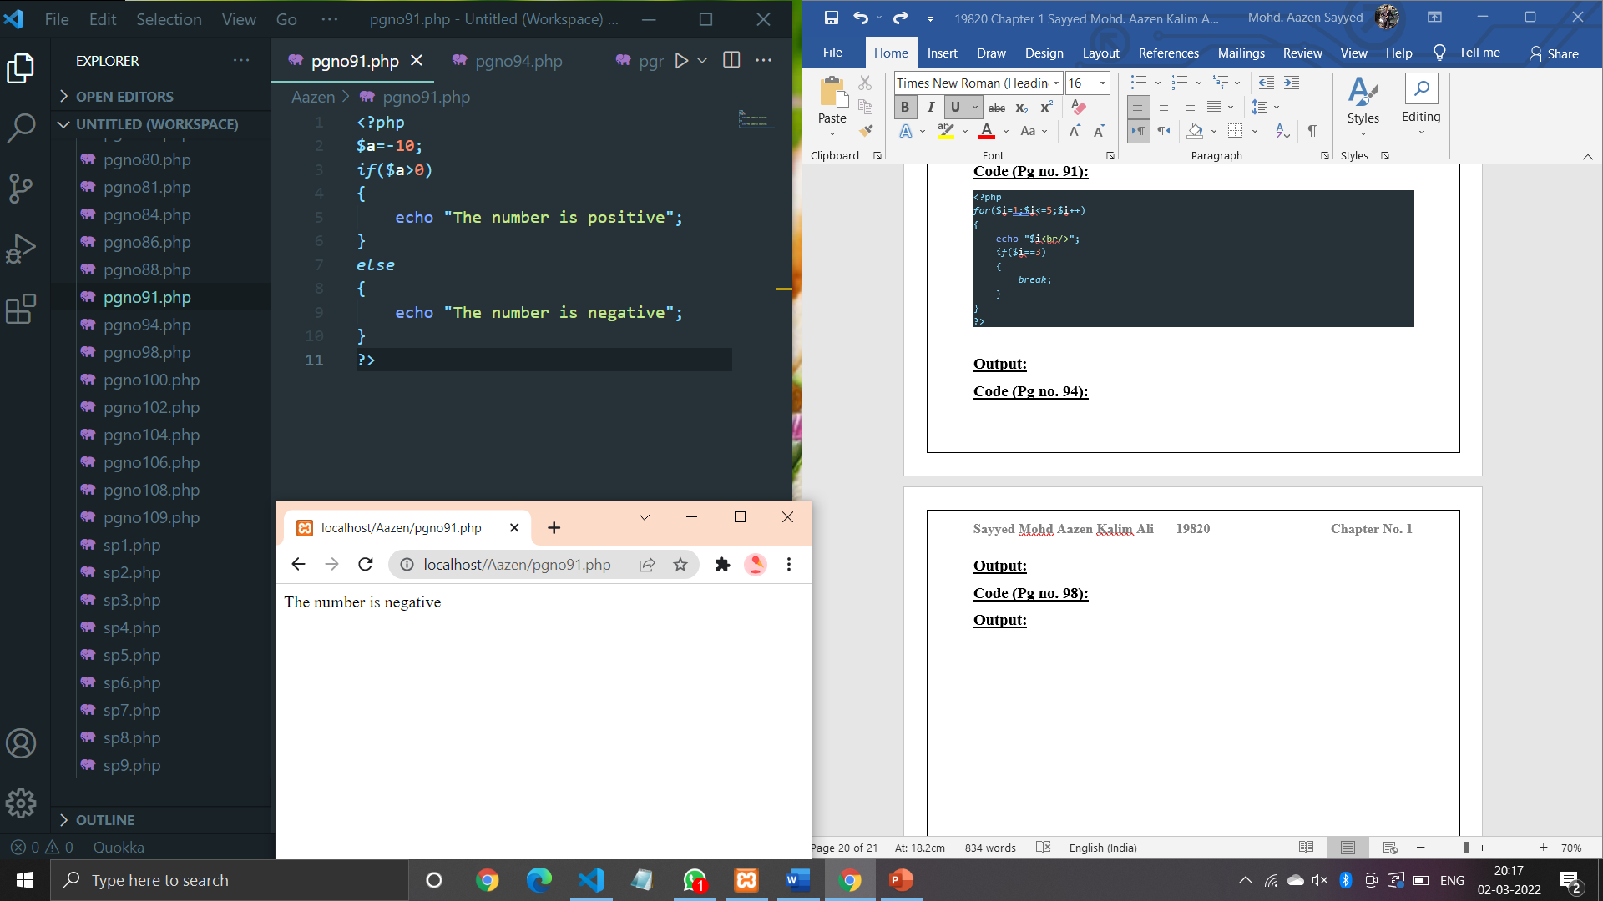

**Code (Pg no. 94):**

<?php

$per=65;

*if*($per>=75)

{

    echo "Distinction";

}

*else* *if*($per<75 && $per>=60)

{

    echo "First Class";

}

*else* *if*($per<60 && $per>=45)

{

    echo "Second Class";

}

*else* *if*($per<45 && $per>=40)

{

    echo "Pass Class";

}

*else*{

    echo "Sorry Fail";

}

?>

**Output:**

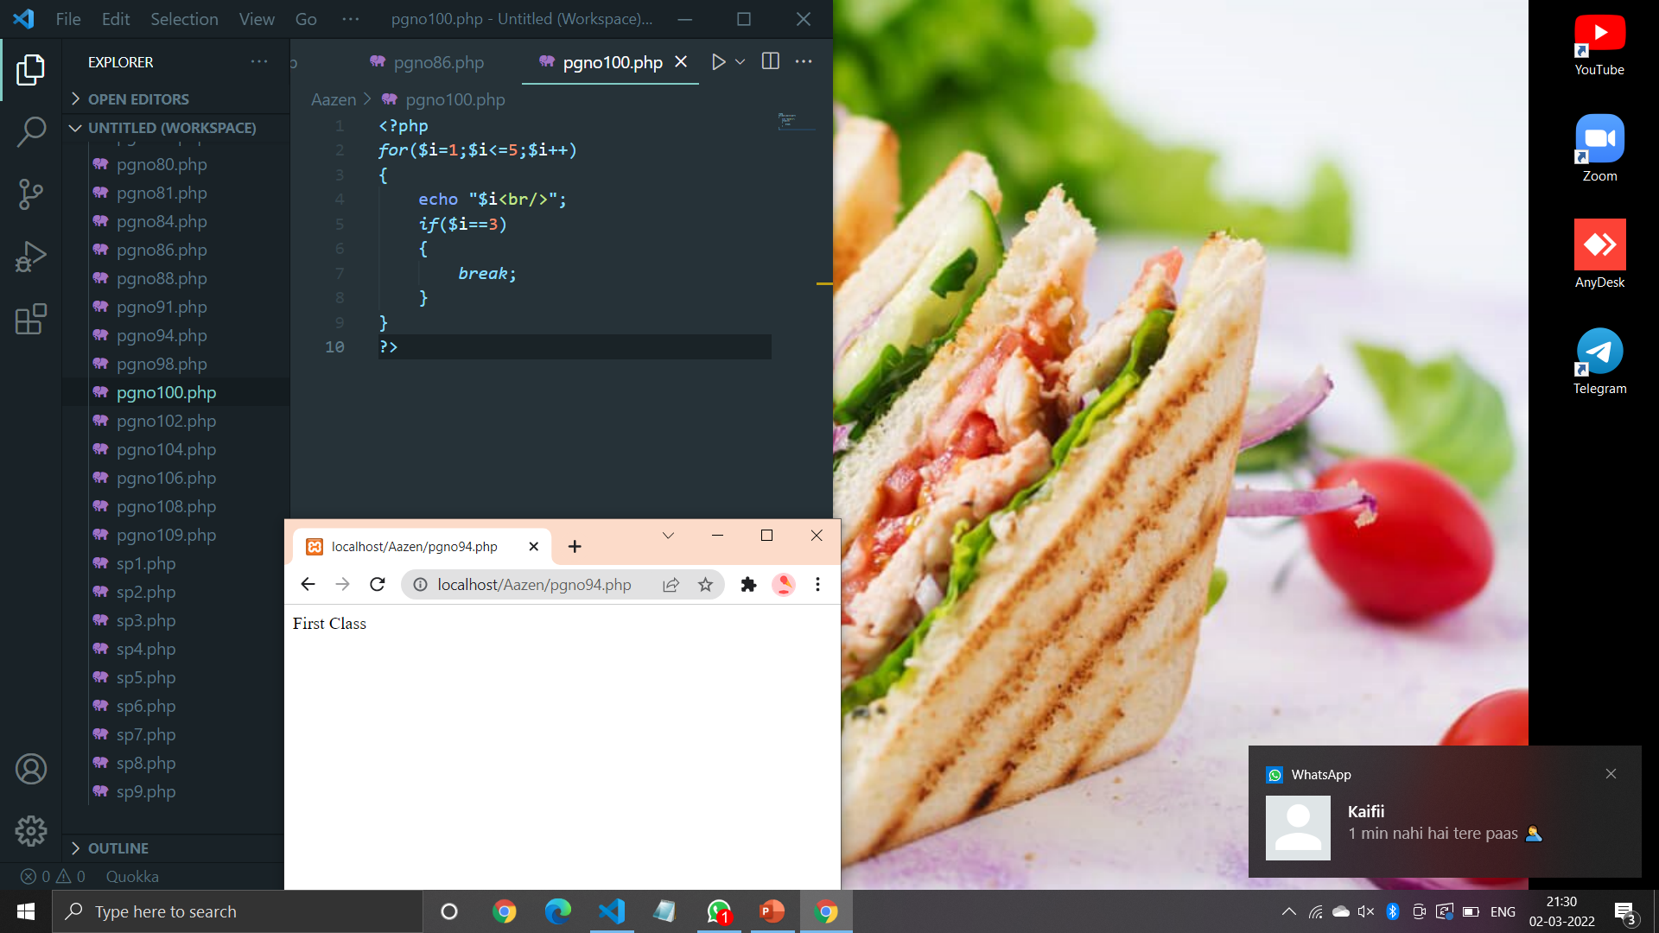

**Code (Pg no. 98):**

<?php

$ch=1;

$a=20;

$b=10;

*switch*($ch)

{

*case* 1:

        $c=$a+$b;

        echo "Addition =".$c;

*break*;

*case* 2:

        $c=$a-$b;

        echo "Subtraction =".$c;

*break*;

*case* 3:

        $c=$a*$b;

        echo "Multiplication =".$c;

*break*;

*case* 4:

        $c=$a/$b;

        echo "Division =".$c;

*break*;

*default*:

        echo "Wrong Choice";

}

?>

**Output:**

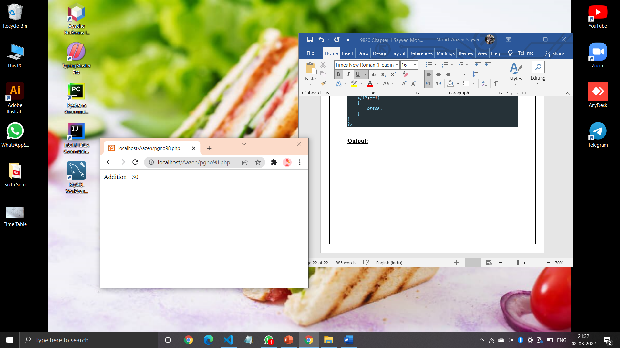

**Code (Pg no. 100):**

<?php

*for*($i=1;$i<=5;$i++)

{

    echo "$i<br/>";

*if*($i==3)

    {

*break*;

    }

}

?>

**Output:**

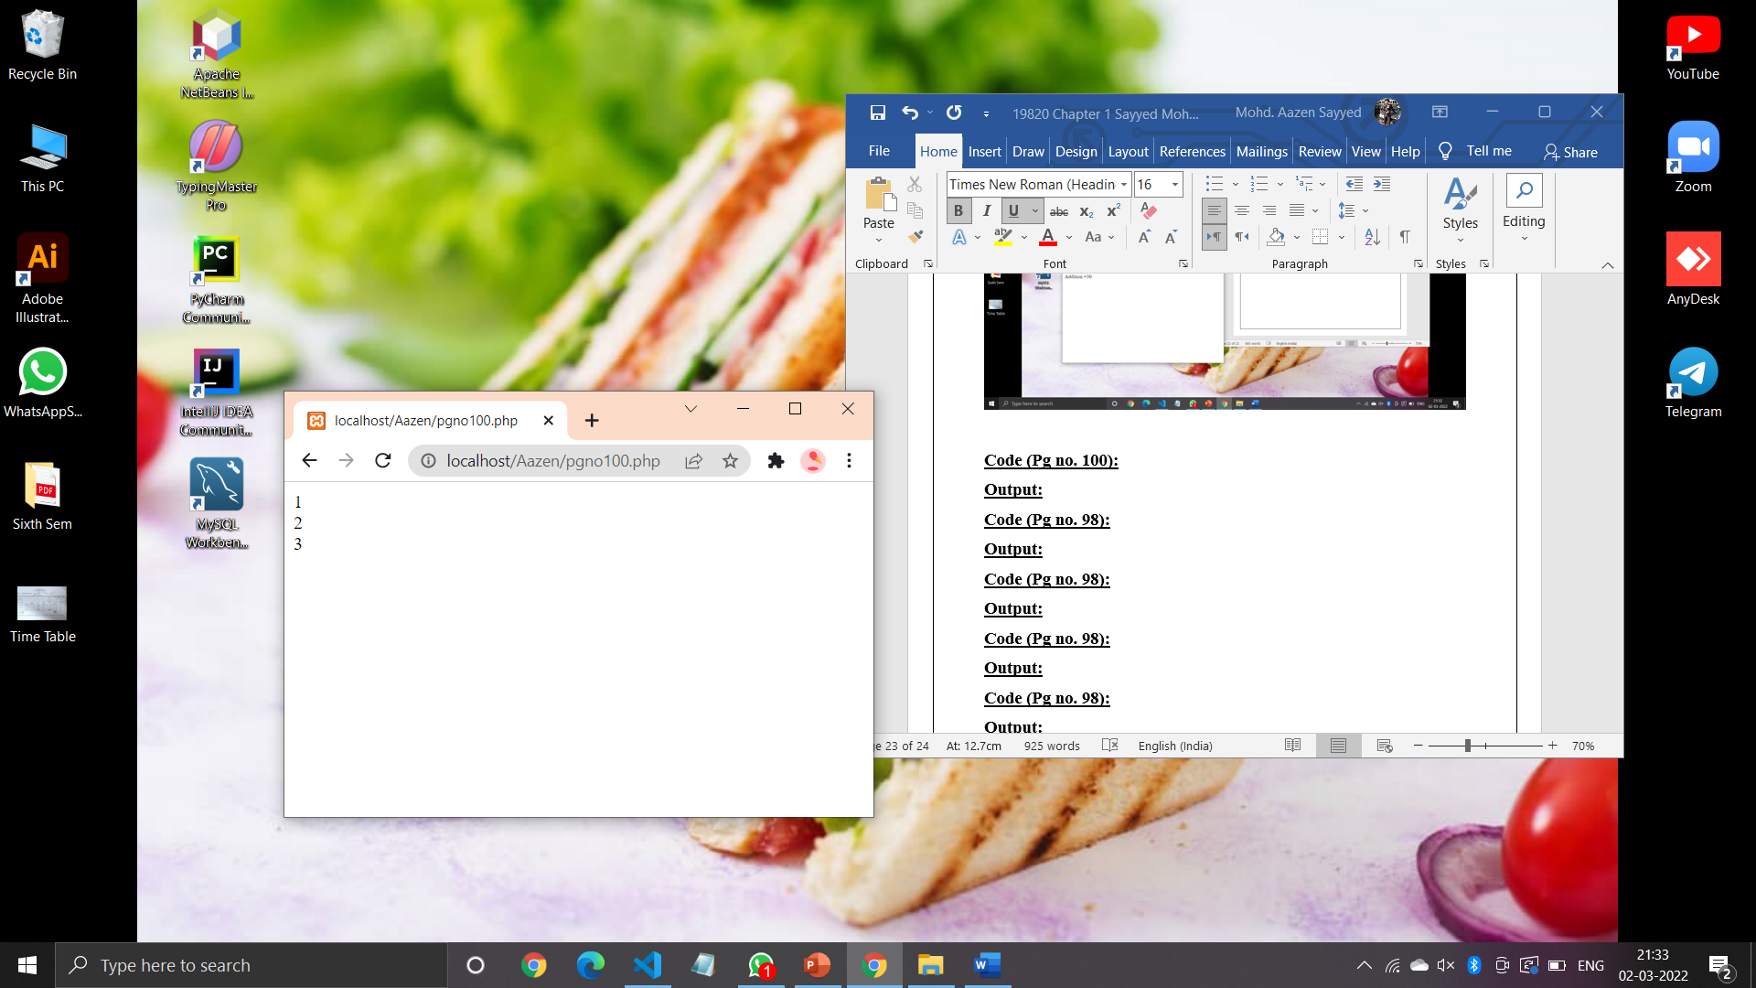

**Code (Pg no. 102):**

<?php

*for*($i=1;$i<=5;$i++)

{

    echo "$i<br/>";

*if*($i==3)

    {

*continue*;

    }

    echo "$i<br/>";

}

?>

**Output:**

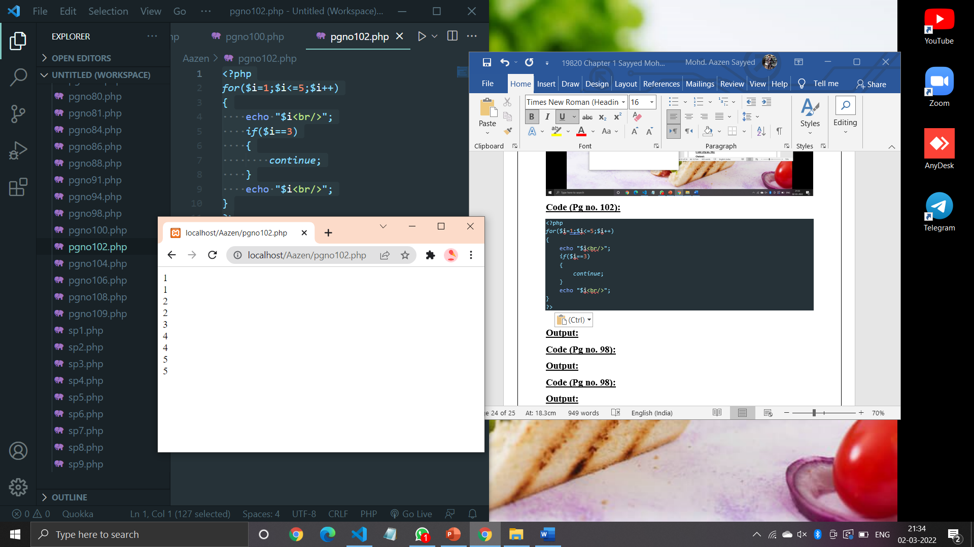

**Code (Pg no. 104):**

<?php

$i=0;

*while*($i<=10)

{

    echo "$i<br/>";

    $i+=2;

}

?>

**Output:**

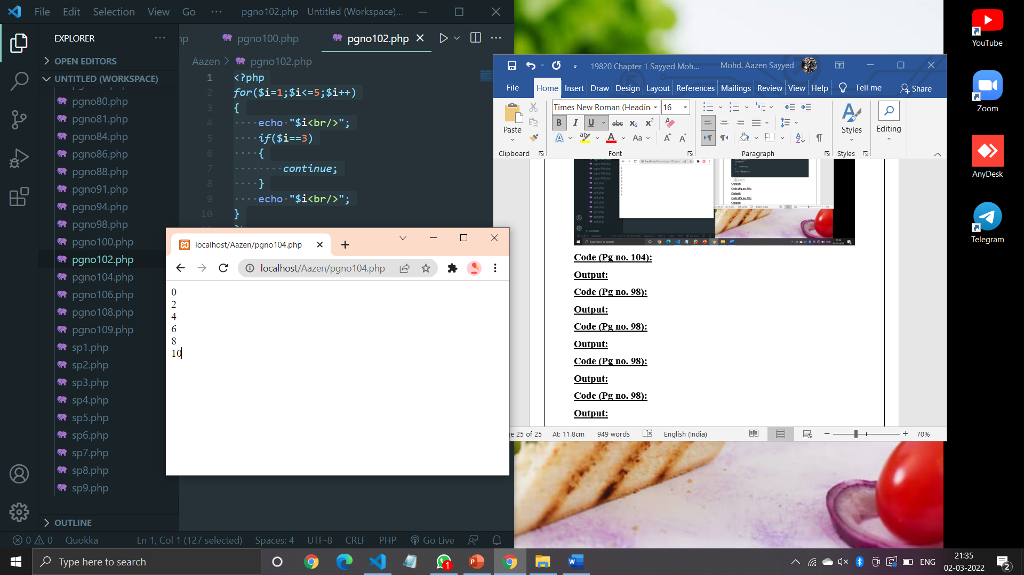

<?php

$i=1;

*do*{

    echo "$i<br/>";

    $i+=2;

}

*while*($i<10);

?>

**Output:**

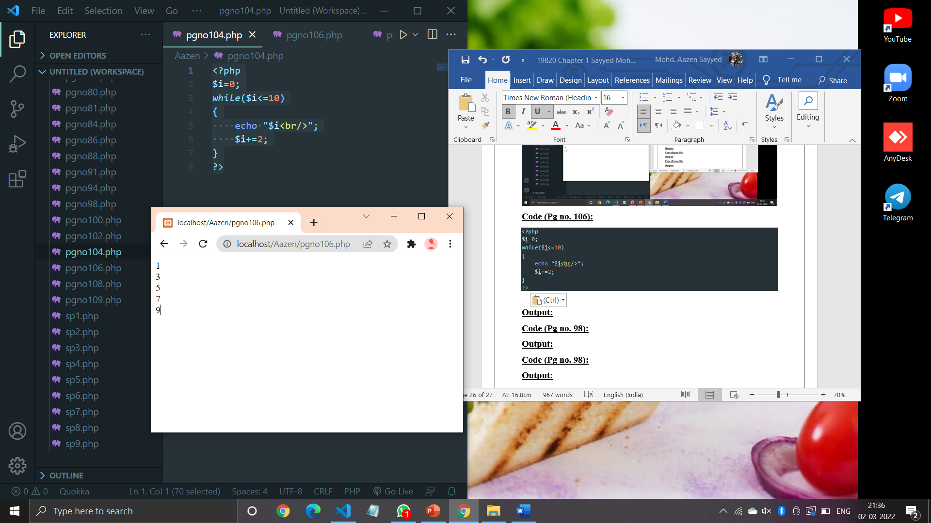

**Code (Pg no. 108):**

<?php

$num=0;

*for*($i=0;$i<=10;$i+=2)

{

    echo "$i<br/>";

    $num+=$i;

}

echo "Sum = $num";

?>

**Output:**

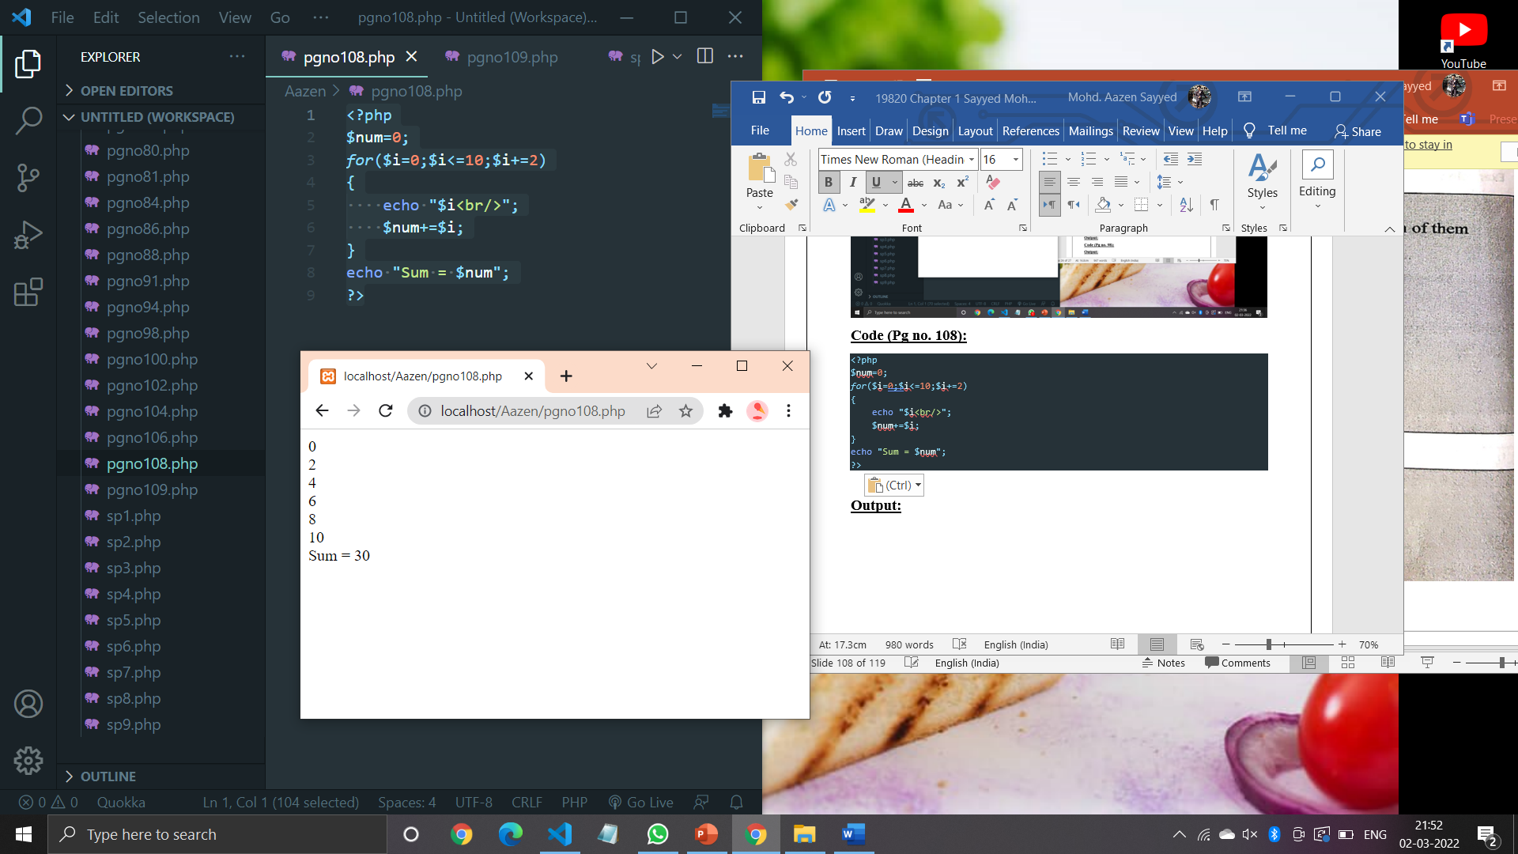

**Code (Pg no. 109):**

<?php

$arr=array(10,20,30,40,50);

*foreach*($arr as $i)

{

    echo "$i<br/>";

}

?>

**Output:**

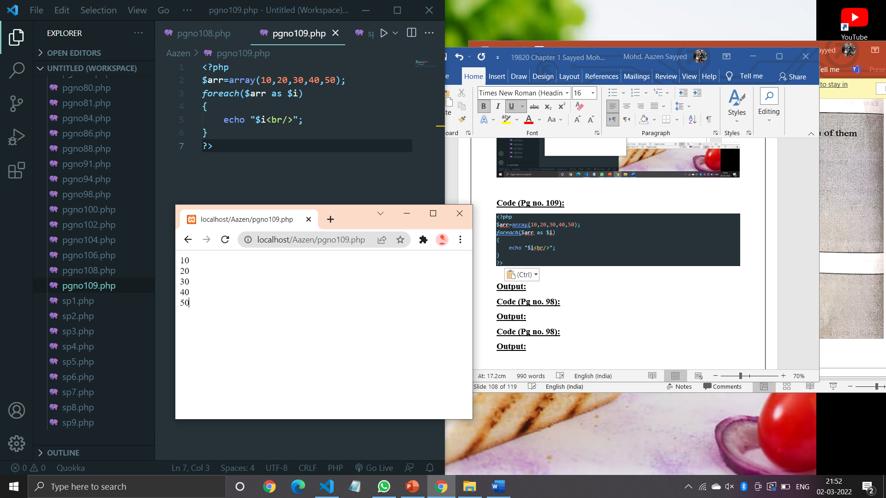

**Code (Pg no. 110):**

<?php

echo ("Welcome to PHP");

?>

**Output:**

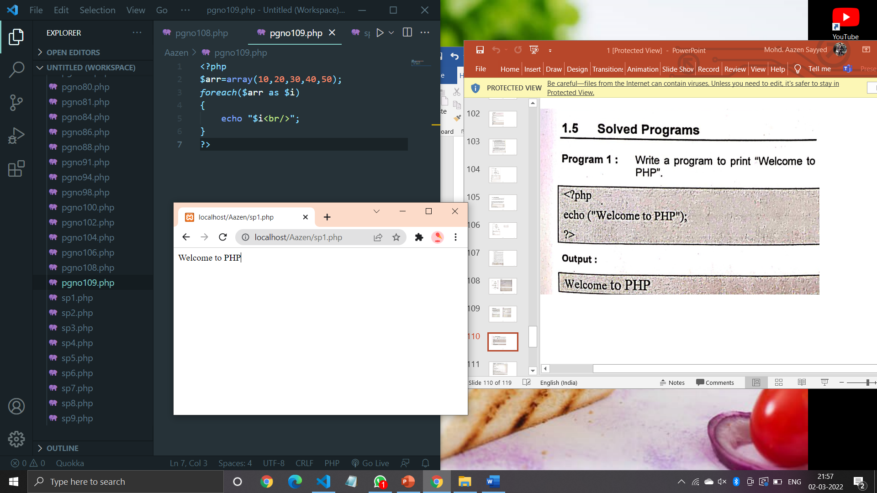

**Code (Pg no. 111):**

<?php

function my_sqrt($n)

{

    $x=$n;

    $y=1;

*while*($x>$y)

    {

        $x=($x+$y)/2;

        $y=$n/$x;

    }

*return* $x;

}

print_r(my_sqrt(16)."<br/>");

print_r(my_sqrt(144)."<br/>");

?>

**Output:**

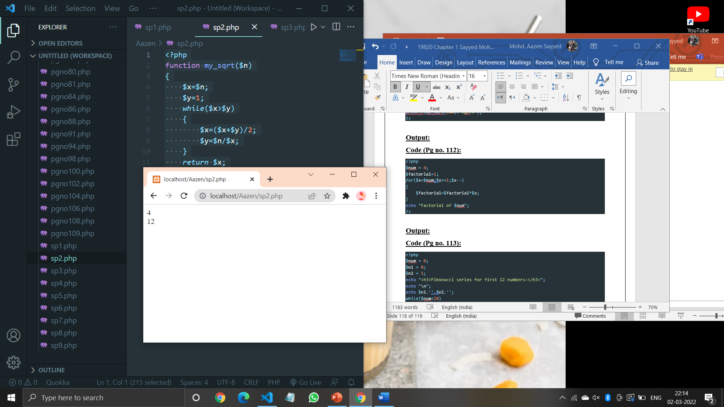

**Code (Pg no. 112):**

<?php

$num = 4;

$factorial=1;

*for*($x=$num;$x>=1;$x--)

{

    $factorial=$factorial*$x;

}

echo "Factorial of $num";

?>

**Output:**

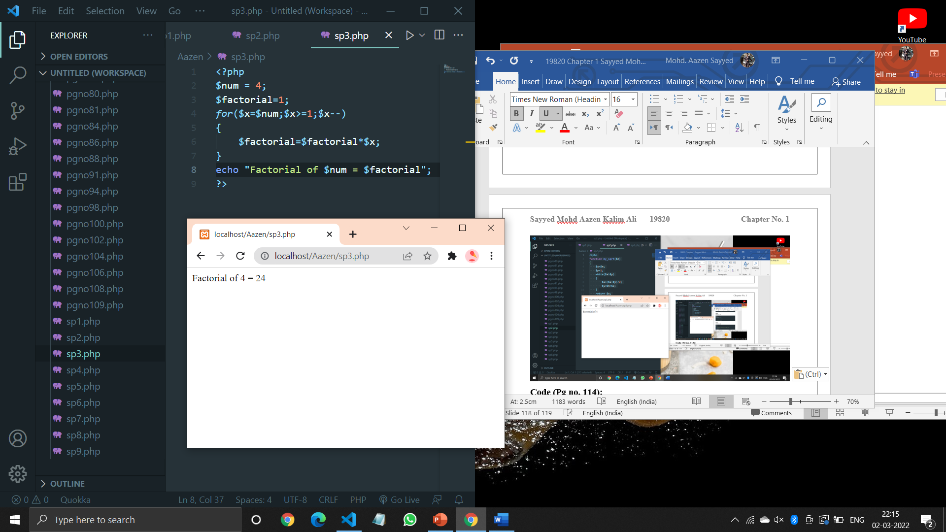

**Code (Pg no. 113):**

<?php

$num = 0;

$n1 = 0;

$n2 = 1;

echo "<h3>Fibonacci series for first 12 numbers:</h3>";

echo "\n";

echo $n1.''.$n2.'';

*while*($num<10)

{

    $n3=$n2+$n1;

    echo $n3.'';

    $n1=$n2;

    $n2=$n3;

    $num=$num+1;

}

?>

**Output:**

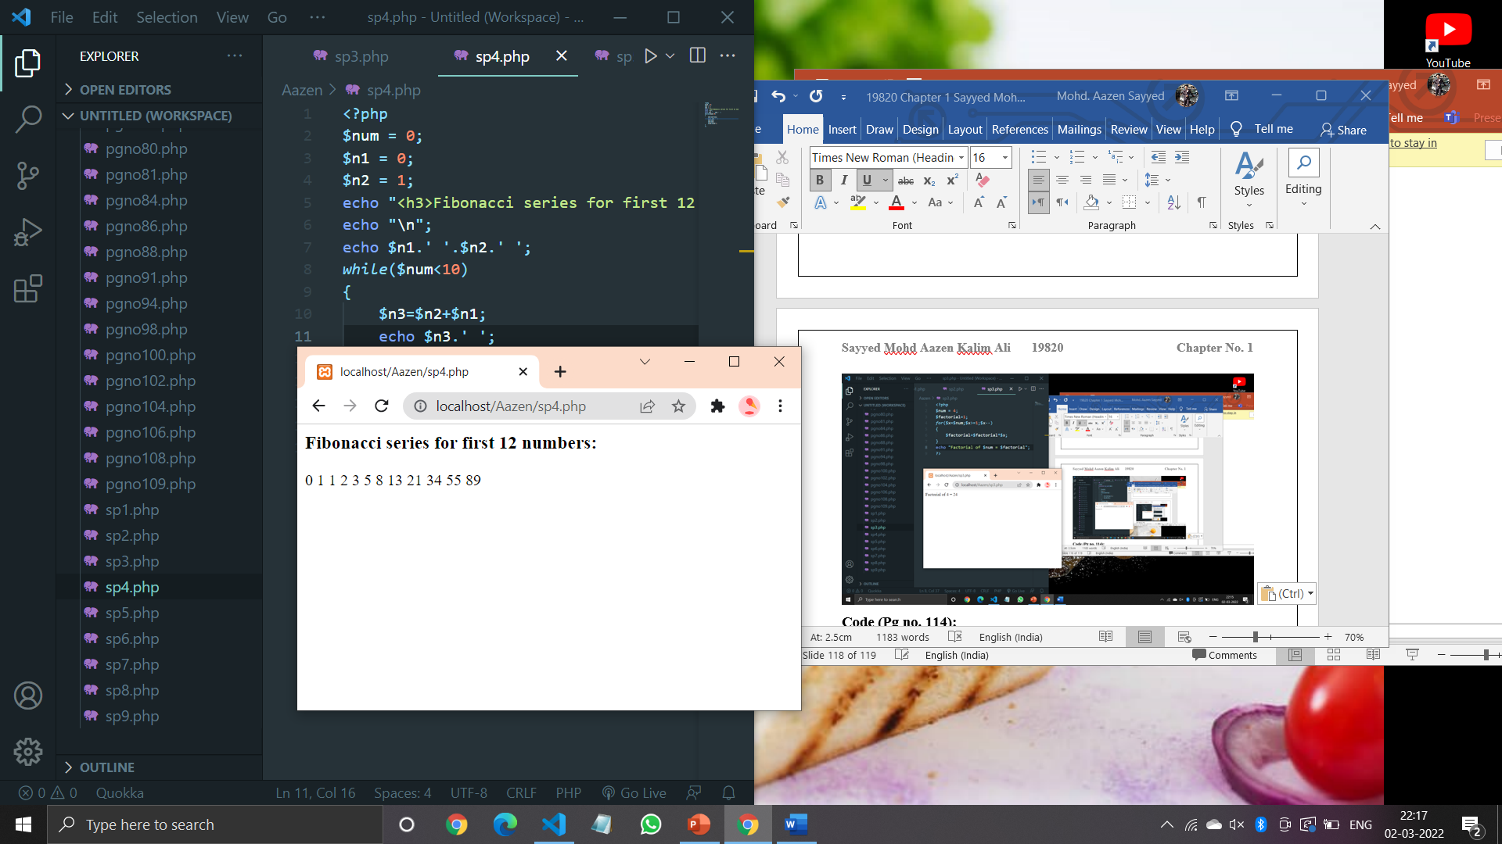

**Code (Pg no. 114):**

<?php

$count=0;

$number=2;

*while*($count<20)

{

    $div_count=0;

*for*($i=1;$i<=$number;$i++)

    {

*if*(($number%$i)==0)

        {

            $div_count++;

        }

    }

*if*($div_count<3)

    {

        echo $number." , ";

        $count=$count+1;

    }

    $number=$number+1;

}

?>

**Output:**

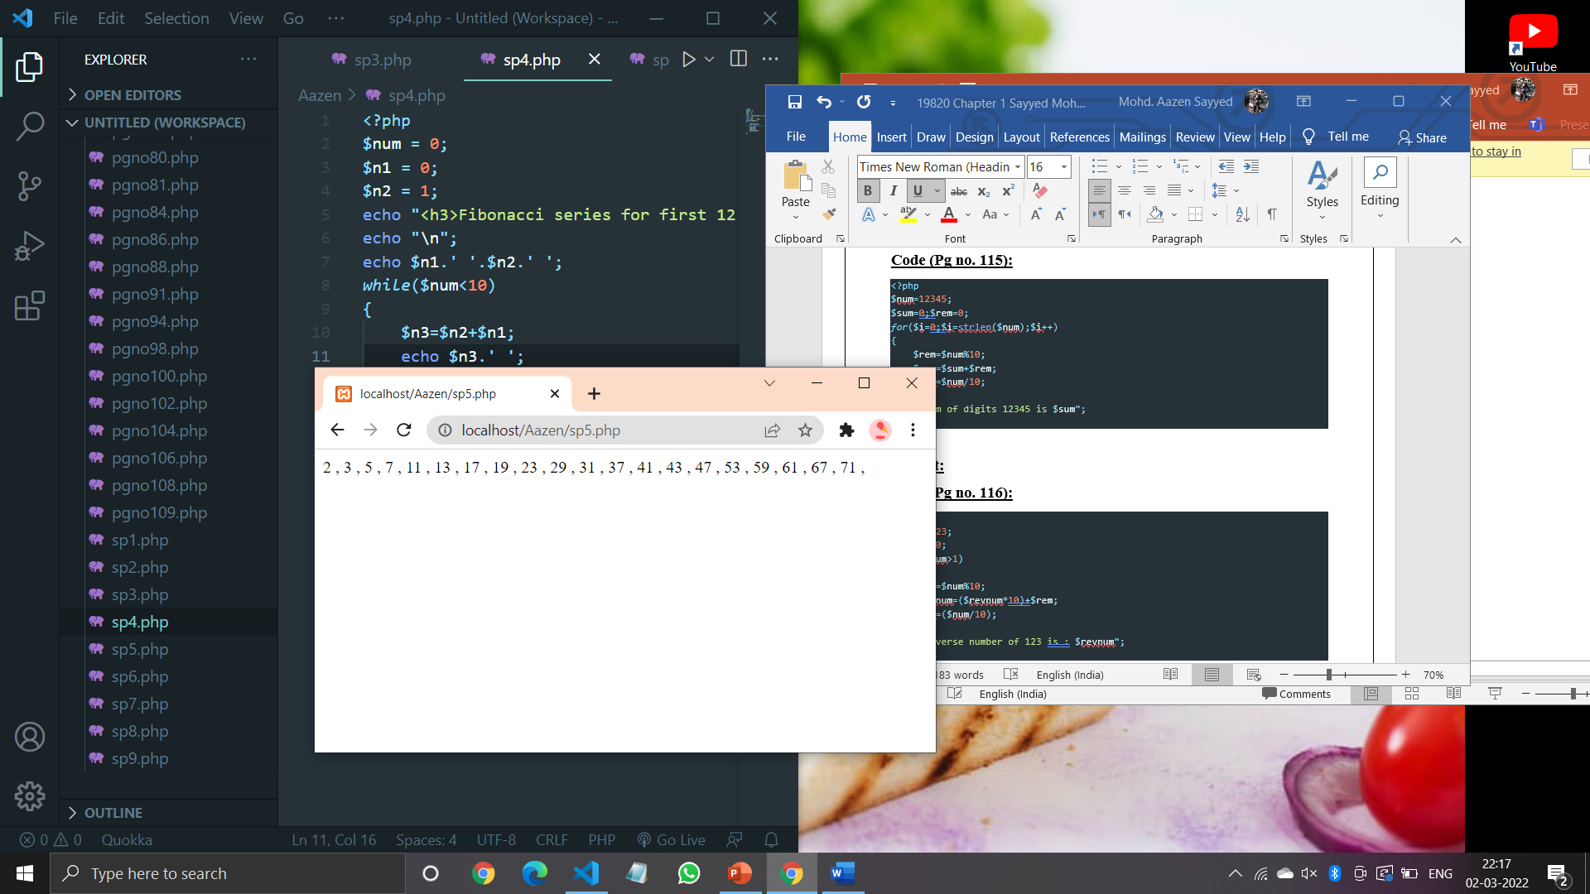

**Code (Pg no. 115):**

<?php

$num=12345;

$sum=0;$rem=0;

*for*($i=0;$i<=strlen($num);$i++)

{

    $rem=$num%10;

    $sum=$sum+$rem;

    $num=$num/10;

}

echo "Sum of digits 12345 is $sum";

?>

**Output:**

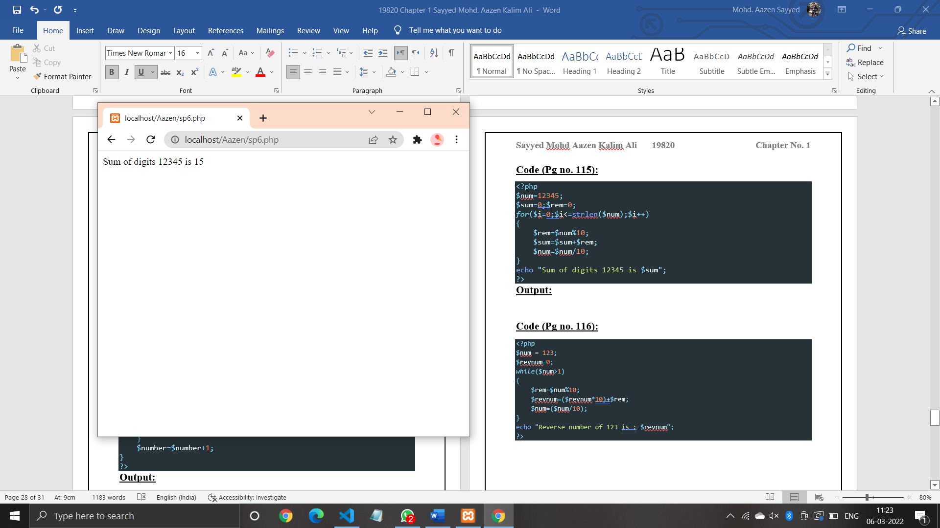

**Code (Pg no. 116):**

<?php

$num = 123;

$revnum=0;

*while*($num>1)

{

    $rem=$num%10;

    $revnum=($revnum*10)+$rem;

    $num=($num/10);

}

echo "Reverse number of 123 is : $revnum";

?>

**Output:**

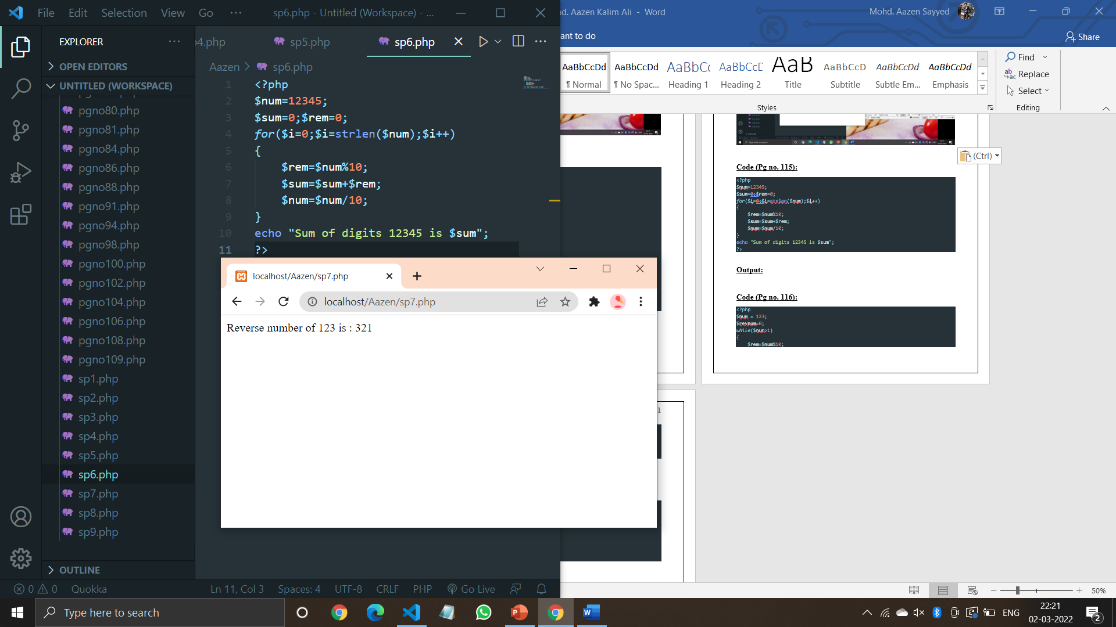

**Code (Pg no. 117):**

<?php

$sum=0;

*for*($i=0;$i<=10;$i+=2)

{

    echo "$i<br/>";

    $sum=$sum+$i;

}

echo "Sum: $sum";

?>

**Output:**

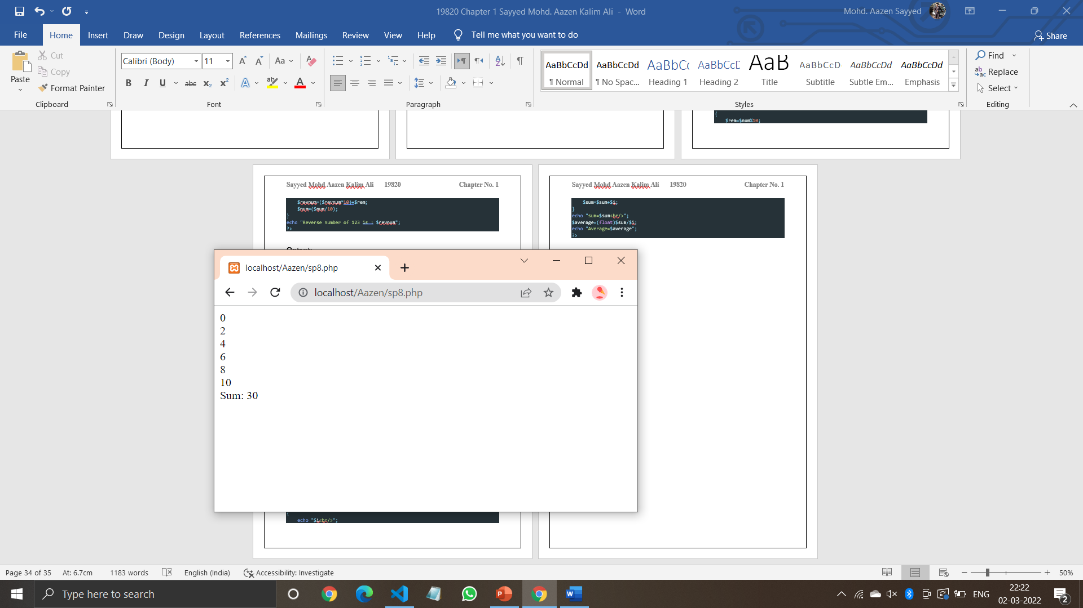

**Code (Pg no. 118):**

<?php

$sum = 0;

*for*($i=1;$i<=10;$i++)

{

    echo "$i<br/>";

    $sum=$sum+$i;

}

echo "sum=$sum<br/>";

$average=(float)$sum/$i;

echo "Average=$average";

?>

**Output:**

